Administrator (Corporate)
September 2019

Dimensions:
Budget: | Budget responsible for: £xx | Scope of Role: | Please detail the scope of the role, does it have responsibility group wide / Business Unit/Local teams
Role Reports to: | Line manager | Team: | x total
About Simplyhealth
Since 1872 – long before the existence of the NHS – Simplyhealth has been helping people manage their everyday healthcare needs so they can make the most of life. That’s why today we ensure over three million people in the UK have access to the health products, services and support that they need, when they need them and at a price they can afford.
Role purpose
Working as part of a team of administrators to deliver excellent customer service to our Corporate clients and intermediaries as part of the Customer Service department.
Be part of the “beating heart” of the department by taking ownership, care and consideration over every piece of work processed. Remembering that every back office process has an effect on our internal and external customers and the other teams within our department by ensuring work is completed accurately and to agreed timescales.
The role holder will be confident in their skills and ability, operating mostly within familiar areas and boundaries of their role. They will have ownership for achieving and improving personal performance, acting on opportunities in their role and seeking new opportunities to develop. A focus will be on achieving personal goals/daily targets and having a personal impact on the goals set for the wider team. They will be open to personal feedback and work on leveraging strengths in their development areas whilst building positive relationships with team members and stakeholders, showing an awareness of different perspectives and styles. They will be confident to speak up in meetings and state their opinions, spotting opportunities and escalating issues to improve their own performance and processes and costs at team level. They will follow well defined priorities within a given framework and manage with a small degree of ambiguity and will have a clear understanding of how their role fits into the bigger picture and show curiosity to understand the bigger picture.

Role responsibilities & accountabilities:
Corporate:
Administration of Companies database
- Processing changes to database records and administering requests from companies and intermediaries accurately, ensuring Simplyhealth contact management systems are kept up to date.
- Ensuring deadlines are met and customer expectations are exceeded and standard operating procedures are created and updated for every process.
- Ensuring all communication channels meet the criteria needed and represent our brand to a high standard. E.g. quality checking letters/emails etc
- Updating and changing reports through Microsoft Excel, this including financial information.
- Have good understanding of Corporate products to at time represent Simplyhealth at external roadshows and client meetings
- Prioritising work to take on additional ad-hoc requests from account managers including but not limited to; membership audits, collation of reports and reconciliations

Develop professional relationships
- Excellent communication skills both written and verbal
- Taking inbound calls from our clients and intermediaries - Ensuring clients receive a positive and outstanding experience each and everytime you are in contact with them
- To provide excellent customer service by taking full ownership of queries and following them through to a satisfactory conclusion
- Ensure anything you consider to be a risk to either customer/client experience of the wider business is highlighted in a timely manner and relevant support provided to address the risk
- Continually champion the Simplyhealth values and standards, positively acting as a role model at all times

Support of other Customer Service teams and the wider business:
- Working closely with the Corporate account management and Sales teams to ensure communication channels are clear and proactive
- Offering a proactive service to the Customer Service department looking to deal with risks and queries before they become issues.
- Excellent communication skills both written and verbal, which allow us to respond to client requests in a timely, effective manner adhering to departmental standards and deadlines.
- Flexibility is essential, adapting to a variety of internal and external client needs, with a focus on the solution not the problem.
- Utilise time management and organisation tools to ensure timescales and deadlines are adhered to, including delegating to colleagues and other departments.
- Organisation and Ownership - Taking ownership and responsibility for problem solving for internal and external customers.
- Acting as a database expert to provide excellent customer service to internal teams when supporting them in queries.
- Offering ad-hoc telephone support to phone based teams to help SLAs and be a backbone to the wider department, e.g. covering team meetings and FRM outbound calls to set fees for practices.

Other responsibilities within the role:
Service Development
- Contribution of suggestions to Management team for ways of refining existing processes.
- Assisting Customer Service Project teams on development of new processes and technology (e.g. I.T testing, User Acceptance Testing)

Workflow support:
- Assisting workflow (where necessary) with sorting and logging of incoming postal queries and requests from Denplan customers and member dentists.

Connections:
- Administration Manager, Team Leaders and Seniors
- Administration Team
- Customer Service Department (all teams)
- Customers
- AXA Business Services (Bangalore)
- Professional Services
- IT
- Finance
Sales
- Practice Advisors
- Marketing
- Events
- 3rd party suppliers
Key Experience:
- Previous experience working within an administration and/or financial background
- Evidence of customer focussed previous job roles
- Experience of handling high pressure situations and deadlines
- Educated to degree level or equivalent (desirable)
- Educated to A Level or equivalent standard (desirable)
- GCSE or equivalent at Grade C or above in English and Maths (essential)

Technical

- Professional knowledge – The job requires a good knowledge and comprehensive understanding of the range of processes, procedures and systems to be used in carrying out assigned tasks and a basic understanding of the underlying concepts & principles upon which the job is based. The knowledge can be acquired through a combination of job-related training and considerable on-the-job experience. The skills and knowledge level can be equivalent to a specialized level within a skilled trade, but are generally non-theoretical skills.

- Business expertise –The job requires the understanding of how his assigned duties relate with the others in the team/unit, and how the team integrates with others in accomplishing the work of the area/sub-function. Knowledge of the jobs and responsibilities of others in the team is needed to help the job achieve his/her objectives.

- Problem solving – The job works within well-defined procedures that may involve a variety of work routines. The job will need to understand the procedures and have the capability to evaluate and select the appropriate alternatives from defined options. The job requires the ability to make judgments based on the analysis of factual information.

Behavioural

Anticipate and Accelerate – explaining clearly, analysing problems, seeing opportunities
  - Spotting opportunities and escalating issues to improve own performance and processes and costs at team level.
  - Follow well defined priorities and prioritising within a given framework and managing a small degree of ambiguity.
  - Clear understanding how your role fits into the bigger picture. Showing curiosity to understand the bigger picture.

Drive – self belief, using initiative, aspiring to succeed
- Confident in skills and ability at level, operating mostly within familiar areas and boundaries of role, regularly steps out of personal comfort zone.
- Ownership for achieving and improving personal performance, acting on opportunities in role and seeking new opportunities to develop.
- A focus on achieving personal goals/daily targets and having a personal impact on the goals set for the wider team.

Partner and Trust – inspiring and engaging others, understanding others, understanding myself
- Open to personal feedback and works on leveraging strengths in the development areas.
- Builds positive relationships with team members and stakeholders, aware of different perspectives and styles.
- Credibility based on a good track record. Confidence to speak up in meetings and state your opinions.

Our Values
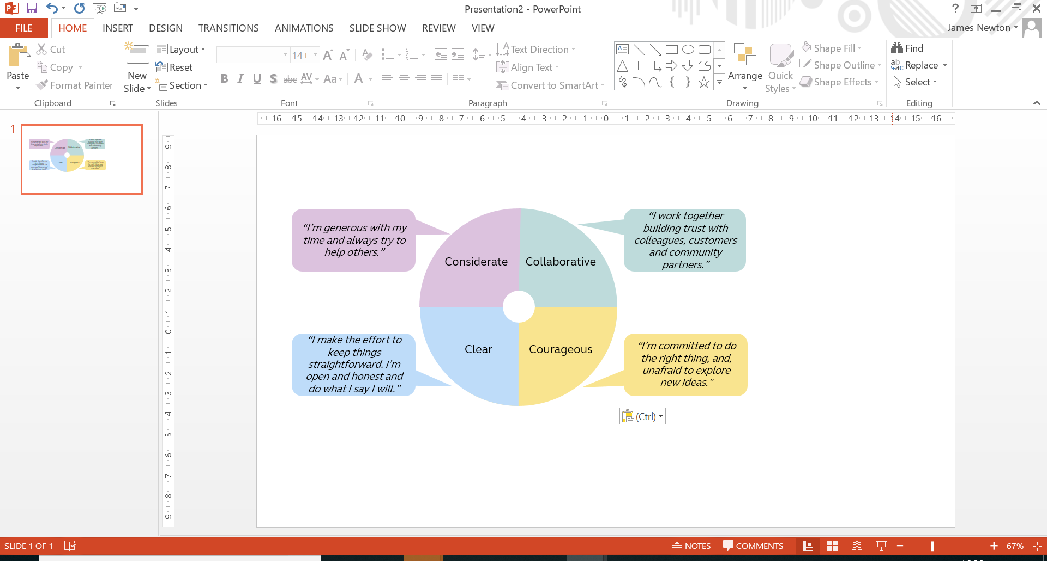

Work arrangements
- Some UK travel & overnight stays
- Reasonable role and task flexibility expected
- May be required to lead other business activities or projects in other parts of the Group

