HR Administrator
November 2021

Dimensions:
Budget: | Budget responsible for: £xx | Scope of Role: | Please detail the scope of the role, does it have responsibility group wide / Business Unit/Local teams
Role Reports to: | Line manager | Team: | x total
About Simplyhealth
Since 1872 – long before the existence of the NHS – Simplyhealth has been helping people manage their everyday healthcare needs so they can make the most of life. That’s why today we ensure over three million people in the UK have access to the health products, services and support that they need, when they need them and at a price they can afford.
Role purpose
Providing transactional first line HR Operational advice and exceptional HR administration support to all Simplyhealth business units.
The role holder will be confident in their skills and ability, operating mostly within familiar areas and boundaries of their role. They will have ownership for achieving and improving personal performance, acting on opportunities in their role and seeking new opportunities to develop. A focus will be on achieving personal goals/daily targets and having a personal impact on the goals set for the wider team. They will be open to personal feedback and work on leveraging strengths in their development areas whilst building positive relationships with team members and stakeholders, showing an awareness of different perspectives and styles. They will be confident to speak up in meetings and state their opinions, spotting opportunities and escalating issues to improve their own performance and processes and costs at team level. They will follow well defined priorities within a given framework and manage with a small degree of ambiguity and will have a clear understanding of how their role fits into the bigger picture and show curiosity to understand the bigger picture.
Role responsibilities & accountabilities:
- Deliver administration excellence thorough out the full employee life cycle, including Recruitment and On boarding, Reward and Benefits, staff changes and life style change requests
- Issue employment contracts and monitor the return of the documentation including employee vetting checks
- Support the compliance and senior management team with SMCR and certified managers including ensuring regulatory references are completed.
- Send notifications to the business with reference to new starters
- Ensure effective telephone, email and online advice for employees and managers is available to enable accurate and speedy information, advice and support
- Supporting with reviewing and adding to the JIRA platform to ensure continuous improvement in enhancing the customer experience.
- Provide a first class service to all customers on a range of employment policies (disciplinary, grievance, family, attendance, recruitment)
- Contacting hiring managers at regular intervals to support with performance or sickness management during the probation period. Escalating to the HRBPs when needed.
- Hit targets for response times (Service level agreement’s) attributed to all HR contact methods
- Maintain the integrity of the HR System by processing accurate data in the HR Systems ensuring that processes are followed and data is regularly cleansed
- Maintain filing and general correspondence, ensuring accuracy, confidentiality and security of information in accordance to data protection guidelines
- To contribute as appropriate to the further development of systems and processes by identifying and then pursuing any opportunities for service improvements
- Where instructed conduct Exit Interviews
- Escalate issues where appropriate to assist the resolution of enquiry
- Assist with ad-hoc projects as directed by HR Operations team in support of key people processes across the HR calendar
- Ensure that you work in a safe manner and remain up to date and comply with the Health & Safety policy statement and procedures and report any incidents to your line manager.
- Managing the Experian checks and working with new starters and hiring managers to ascertain information and payment plans for CCJS. Flagging any concerns with the ASK HR Lead and the HRBP.
- Ensuring all new starters receive and complete their payroll information prior to cut off.
- Administering the Simple Health shopping voucher scheme every month.
- Pro-actively check and provide support to all new starters to ensure that benefits selections are completed within the 28-day window.
- Provide meaningful HR data from the JIRA portal to present to the HR Ops Team.
Connections:
- All employees

Key Experience:
- Worked in an HR administration role
- Worked in a customer focused environment.
- Experience of providing HR telephone advice.
- Experience of HR systems
- Worked on fast paced projects
- Dealt with all level of employees
- Excellent organisational skills
- Can use Microsoft Word, excel, outlook and access
- Strong literacy, numeric skills
- Excellent attention to detail
- CIPD Level 3 would be an advantage

Technical

- Professional knowledge – Job requires a good knowledge and comprehensive understanding of the range of processes, procedures and systems to be used in carrying out assigned tasks and a basic understanding of the underlying concepts & principles upon which the job is based. The knowledge can be acquired through a combination of job-related training and considerable on-the-job experience. The skills and knowledge level can be equivalent to a specialized level within a skilled trade, but are generally non-theoretical skills.

- Business expertise – The job requires a basic understanding of their own area/team and how it interacts with others within the organization sub-function. The work performed by the job is closely related to that of other areas to the extent that their performance is subject to their understanding of how areas coordinate and contribute to the achievement of the objectives of the organization sub-function.

- Problem solving – The job requires the ability to make judgments based on practice and previous experience. This requires the ability to assess the validity and applicability of previous or similar experiences and evaluate options under circumstances that are not covered by procedures.

Behavioural

Anticipate and Accelerate – explaining clearly, analysing problems, seeing opportunities
  - Spotting opportunities and escalating issues to improve own performance and processes and costs at team level.
  - Follow well defined priorities and prioritising within a given framework and managing a small degree of ambiguity.
  - Clear understanding how your role fits into the bigger picture. Showing curiosity to understand the bigger picture.

Drive – self-belief, using initiative, aspiring to succeed
- Confident in skills and ability at level, operating mostly within familiar areas and boundaries of role, regularly steps out of personal comfort zone.
- Ownership for achieving and improving personal performance, acting on opportunities in role and seeking new opportunities to develop.
- A focus on achieving personal goals/daily targets and having a personal impact on the goals set for the wider team.

Partner and Trust – inspiring and engaging others, understanding others, understanding myself
- Open to personal feedback and works on leveraging strengths in the development areas.
- Builds positive relationships with team members and stakeholders, aware of different perspectives and styles.
- Credibility based on a good track record. Confidence to speak up in meetings and state your opinions.

Our Values
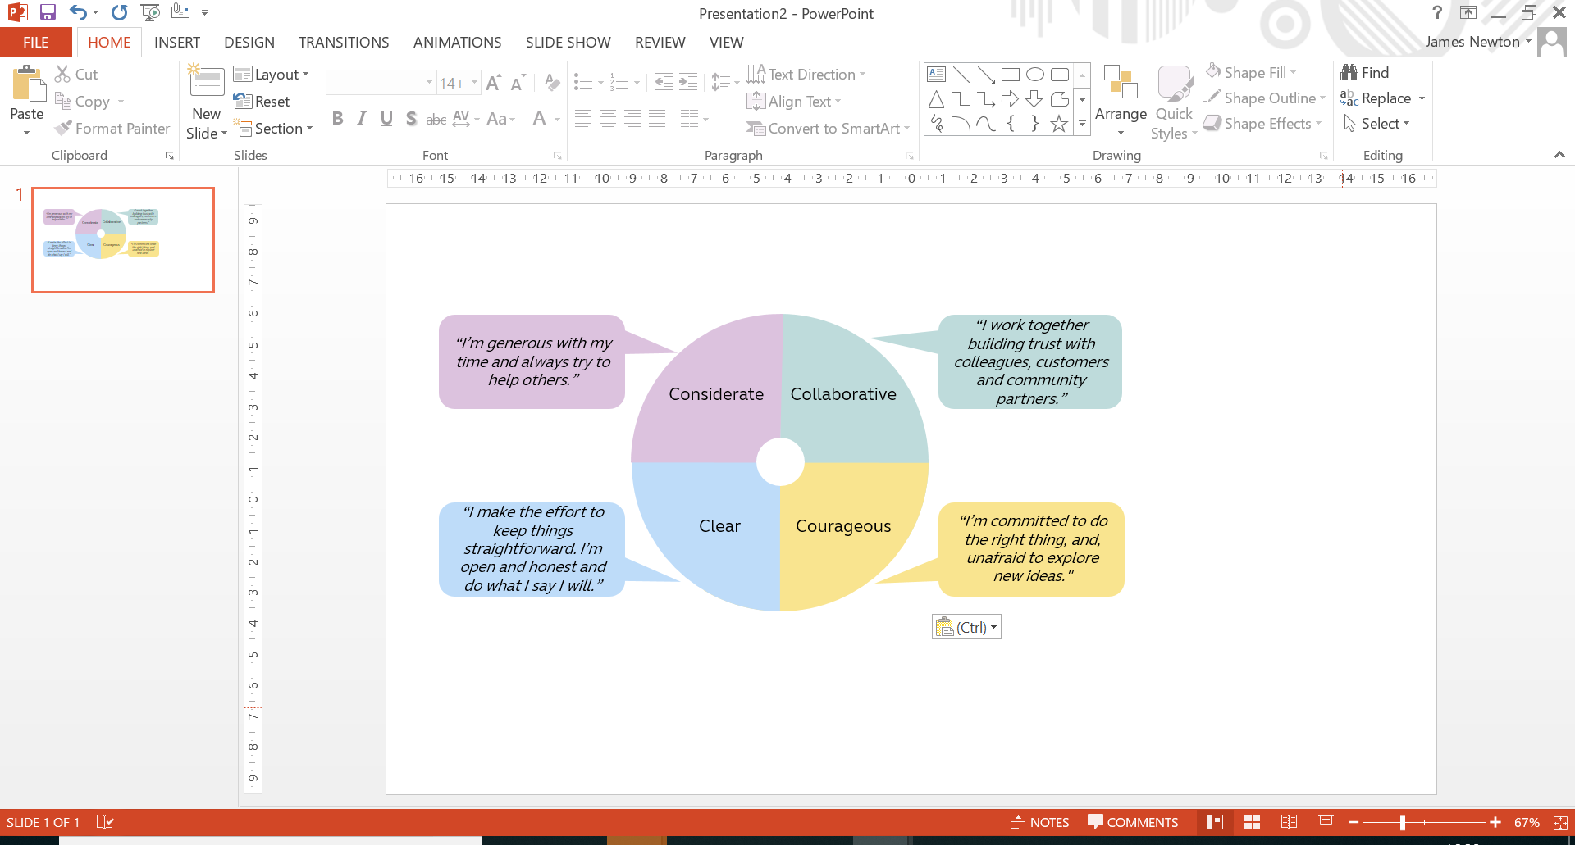

Work arrangements
- Some UK travel & overnight stays
- Reasonable role and task flexibility expected
- May be required to lead other business activities or projects in other parts of the Group

