IT Service Desk Analyst
May -2025

Dimensions:
Budget: | Budget responsible for: £0 | Scope of Role: | Group wide
Role Reports to: | IT Service Desk Manager | Team: | 0 total
About Simplyhealth
Since 1872 – long before the existence of the NHS – Simplyhealth has been helping people manage their everyday healthcare needs so they can make the most of life. That’s why today we ensure over three million people in the UK have access to the health products, services and support that they need, when they need them and at a price they can afford.
Role purpose
To provide right first-time handling of all IT incidents, problems and requests into the IT Service Desk. Negotiating and coordinating rapid and appropriate responses, channelling to appropriate support teams for resolution, monitoring progress, and keeping customers appraised of progress.
Your Role will require you to provide Service Desk support to all business areas within the agreed SLA’s and KPI’S. The role holder will be confident in their skills and ability, operating mostly within familiar areas and boundaries of their role.
They will be open to personal feedback and work on leveraging strengths in their development areas whilst building positive relationships with team members and stakeholders, showing an awareness of different perspectives and styles.
They will be confident to speak up in meetings and state their opinions, spotting opportunities and escalating issues to improve their own performance and processes and costs at team level.
Role responsibilities & accountabilities:
- Ensure all incidents, problems and requests for assistance are properly logged, correctly prioritised, assigned and responded to in a timely manner in accordance with agreed service level standards and procedures
- Ensure that internal customer standards are met and reviewed in line with business expectations
- Maintain good relationships with customers and fellow support staff to assist with communications and swift resolution of issues
- Negotiate with customers and IT staff in respect of emergencies, withdrawal of services, routine and unscheduled maintenance, and the introduction of major amendments to the provision of services
- Manages the expectation of all Simplyhealth staff through necessary verbal and electronic communication
- Adherence to escalation procedures for service incident management. Responds to escalated, complex and high impact user calls in a timely fashion
- Ensures regular administrative and housekeeping activities are conducted using appropriate tools and procedures

Connections:
- IT Service Delivery Manager
- Business Customers across all of SimplyHealth at all levels.
- 1st, 2nd and 3rd line support engineers.
- Central Technology Management

Key Experience:
- Proven experience of working in an IT Service Desk environment including logging, supporting and resolving incidents across multiple technologies.
- Resolving tickets under stated service level agreements
- Proven experience of face to face and remote support
- Confidence to communicating across all levels of the business.
- High levels of initiative and ability to work with minimal support.
- Problem management.

Technical

- Professional knowledge – The job requires a good knowledge and comprehensive understanding of the range of processes, procedures and systems to be used in carrying out assigned tasks and a basic understanding of the underlying concepts & principles upon which the job is based. The knowledge can be acquired through a combination of job-related training and considerable on-the-job experience. The skills and knowledge level can be equivalent to a specialized level within a skilled trade, but are generally non-theoretical skills.

- Business expertise – The job requires a good understanding of how the team integrates with other teams in order to achieve overall objectives of the area. This “integration” refers to the way teams coordinate their efforts and resources to achieve shared and individual objectives. Where a job has broad responsibilities, it will need to have business acumen that goes beyond the team. jobs that involve communication and coordination of people and resources across different teams will need to understand the way these complement and support each other.

- Problem solving – The job requires the ability to make judgments based on practice and previous experience. This requires the ability to assess the validity and applicability of previous or similar experiences and evaluate options under circumstances that are not covered by procedures.

Behavioural

Anticipate and Accelerate – explaining clearly, analysing problems, seeing opportunities
  - Spotting opportunities and escalating issues to improve own performance and processes and costs at team level.
  - Follow well defined priorities and prioritising within a given framework and managing a small degree of ambiguity.
  - Clear understanding how your role fits into the bigger picture. Showing curiosity to understand the bigger picture.

Drive – self-belief, using initiative, aspiring to succeed
- Confident in skills and ability at level, operating mostly within familiar areas and boundaries of role, regularly steps out of personal comfort zone.
- Ownership for achieving and improving personal performance, acting on opportunities in role and seeking new opportunities to develop.
- A focus on achieving personal goals/daily targets and having a personal impact on the goals set for the wider team.

Partner and Trust – inspiring and engaging others, understanding others, understanding myself
- Builds positive relationships with team members and stakeholders, aware of different perspectives and styles.
- Open to personal feedback and works on leveraging strengths in the development areas.
- Credibility based on a good track record. Confidence to speak up in meetings and state your opinions.

Our Values
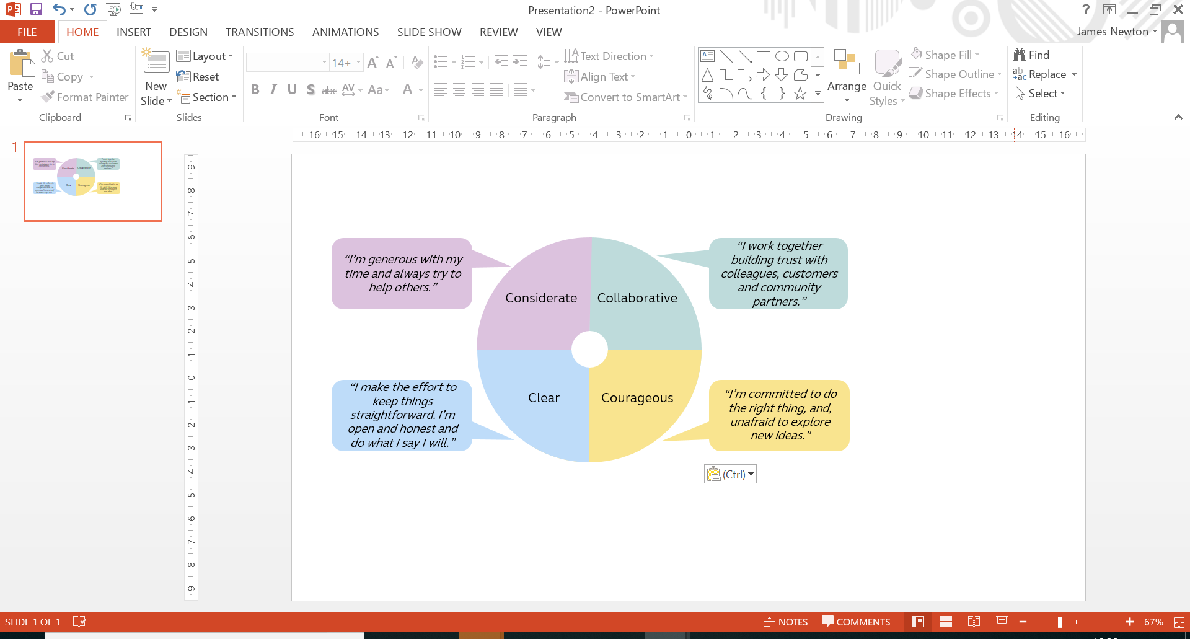

Work arrangements
- Reasonable role and task flexibility expected
- May be required to lead other business activities or projects in other parts of the Group

