Senior Product Manager

Job Family: | Product | Line of Business: | Healthplan
Reports to: | Head of Product | Team size:
Our Purpose & Vision
For over 150 years, Simplyhealth has improved access to UK healthcare, long before the NHS existed
Today, as a certified B-Corp, we continue to modernise in ways that matter deeply to our c.2.5 million members, our customers, and our people.

Our purpose is simple and ambitious: to improve access to healthcare for all in the UK
Through affordable health and dental plans, we help people manage their everyday healthcare needs and live healthier lives. With NHS pressures and the cost-of-living crisis making access to care harder, our mission is more critical than ever.
We have ambitious plans to play a much broader role in UK healthcare as a health solutions provider, supporting the NHS through the provision of outpatient support. This will be achieved though expanding both our customer base and service offering, to ensure it has the greatest possible impact on access to healthcare in the UK.

Our vision
With growing pressure on the NHS, Simplyhealth’s products are more essential than ever. But our ambition goes further: we aim to democratise healthcare by making it more affordable and accessible for everyone in the UK. By 2030, Simplyhealth Group will be the UK’s most trusted health navigation and access marketplace that delivers easy to find, affordable services, including our own provision of primary care and financial products that measurably improves outcomes for employees, individuals and providers.

What we do

Simplyhealth is the UK’s leading health plan provider. Its health plans help customers claim cash back for everyday outpatient healthcare treatments carried out by dentists, opticians, physiotherapists, chiropractors, and many more. The plans increasingly also help individuals navigate a complex health care landscape and provide access to care through clinically validated healthcare partners. Simplyhealth helps employers to improve the health and wellbeing of their employees through its My Health service which gives access to GP services, a 24/7 advice and counselling helpline and a wealth of health advice and information.

It is also the UK’s leading dental payment plan provider. Its Denplan payment plan was developed almost 40 years ago by dentists, for dentists, and continues to support dental customers in budgeting for preventative dental care and to avoid future problems. As a company limited by guarantee with no shareholders, Simplyhealth reinvests its profits to benefit its customers and communities, now and in the future.

Our Group strategy
Simplyhealth Group is building the UK’s trusted health access platform, one place to find, book and pay for care, with clear prices, quality you can trust, and optional, fair point-of-need payment options. We focus on what matters most: fast access, less friction, and measurably better outcomes. By 2030, our aim is to be the most trusted way to navigate and access care across the UK, strengthened by our own provision of primary care where it materially improves speed, experience and value.

For employers, we keep their workforce healthy, productive, and engaged by offering affordable, scalable healthcare solutions that reduce absenteeism, support mental health, and deliver measurable ROI by tracking retention, speed of access, and reduced absence.

For working adults using the platform, we aim to make healthcare feel simple again. From the first click, they see real options, real prices and clear next steps, and they can book and pay their way. Helping them take control of their health without the wait, confusion, or financial strain.

Our strategy is focused on helping people to Find the care they need and Fund the care they need affordably so ultimately, they can Flourish
Role Overview
As a Senior Product Manager, you will leverage your proven extensive product experience, established over a number of years, to lead strategically significant initiatives that deliver measurable value for our Healthplan customers and the business. You will identify and shape key product opportunities, develop clear product strategy, and lead cross-functional teams to deliver these outcomes successfully.
Operating as a senior individual contributor, you will balance deep ownership of your product area with broader leadership responsibilities—coaching and developing other product professionals, influencing stakeholders across the organisation, and contributing to the overall strength and maturity of product management at Simplyhealth.

Key Responsibilities & Accountabilities:
Strategic Leadership
- Lead a defined product area, owning the product lifecycle from discovery to delivery across one or multiple squads (includes product vision, strategy, roadmaps and KPIs

- Establish product strategies across lifecycle
- Identify, frame and prioritise strategic product opportunities aligned with business goals and customer needs and regulatory expectations
- Develop comprehensive product strategies and roadmaps for high-impact product areas
- Set ambitious, measurable goals for your product area and determine how to meet them
- Balance short-term business needs with long-term product vision and sustainability
- Influence and contribute to wider product strategy by sharing insights, learnings, and best practice

Product Management & Delivery
- Lead cross-functional teams through the full product lifecycle, from discovery to delivery and optimisation
- Champion continuous discovery to deeply understand customer, clinician, and business needs and ensure insights directly shape decisions
- Systematically review and evaluate market & customer requirements ensuring the outputs inform product delivery
- Make data-informed decisions, balancing qualitative insight, quantitative performance data, cost, risk, and customer value
- Define, own, and track key product performance indicators to measure success and drive continuous improvement
- Conduct and synthesise market, customer, and competitor research to identify trends, threats, and opportunities
- Proactively manage risks, dependencies, and trade-offs within strategically significant initiatives
- Contribute to commercial thinking, including benefits realisation, value tracking, and business case development where appropriate
- Prepares and coordinates product introductions and updates

Decision-Making Authority
- Own prioritisation and scope decisions within your product area
- Make clear trade-offs within agreed strategic, regulatory, and organisational constraints
- Recommend investment, sequencing, and focus to senior leaders
- Exercise sound judgement in complex or ambiguous situations, escalating only when required by material risk or strategic impact

Team & Product Leadership
- Coordinate across squads to ensure a coherent product direction and consistent customer experience
- Lead planning and prioritisation processes aligned to broader organisational goals
- Work closely with Product Managers leading individual squads, providing strategic direction without direct line management

- Actively coach and develop other Product Managers to strengthen strategic thinking, delivery capability, and product craft
- Foster a culture of experimentation, learning and continuous improvement
- Actively contribute to growing product management capability across Simplyhealth through knowledge sharing, workshops, and community building

Stakeholder & Collaboration Management
- Build strong, trusted relationships across all levels of the organisation
- Clearly communicate product vision, strategy, progress, and outcomes to diverse stakeholder groups
- Influence and align teams without direct authority, navigating competing priorities with empathy and clarity
- Work collaboratively with Engineering, Design, Data, Marketing, Sales, Risk, Compliance, and Service teams to deliver cohesive and compliant products with engineers, designers, suppliers, customers
- Act as a thoughtful partner to Risk and Compliance, embedding quality, safety, and regulatory considerations early in discovery and delivery

Risk, Quality & Regulation
- Proactively identify and manage delivery, product, and regulatory risks
- Ensure compliance, quality, and governance considerations are balanced effectively with innovation
- Promote appropriate controls and assurance without compromising customer value or team momentum

Measures of Success

You will be successful in this role when you:
- Deliver measurable customer and business outcomes for your product area
- Demonstrate clear strategic thinking, sound prioritisation, and effective trade-off decisions
- Improve product performance against agreed KPIs
- Build strong partnerships with cross-functional and business stakeholders
- Positively impact the maturity, confidence, and effectiveness of product management across the organisation

Key Experience & Skills:

Essential
- Strong track record in product management (typically 5 years experience), delivering impactful digital or service-enabled products over a sustained period.
- Experience developing and executing product strategy and roadmaps for complex product areas
- Experience working in regulated environments (e.g. FCA, MHRA)
- Strong leadership presence with the ability to influence and align diverse stakeholders
- Excellent communication skills, with confidence operating at all organisational levels
- Data-driven approach to prioritisation and decision-making
- Experience coaching, mentoring, or developing other team members
- Strong strategic thinking and problem-solving capability

Nice to Have
- Experience within healthcare or adjacent sectors
- Experience managing or formally leading other Product Managers
- Experience leading transformational change within larger or complex organisations
- Experience applying agile and lean practices pragmatically within product delivery
Key Connections
- Product leadership team
- Cross-functional delivery teams (Engineering, Design, Data)
- Business Leads and Service teams
- Senior stakeholders across the organisation
- Risk and Compliance teams
- Sales and Marketing teams

Our Culture and Values
We need to act with courage and curiosity to unlock opportunities for customers, colleagues, and communities. We operate with trust and kindness delivering what customers need and supporting colleagues to be their best. We live our All together healthier ethos, focusing on self-care and nurturing relationships.

Simplyhealth’s cultural ambition can be summarised as doing the right thing: by its customers, its people, its communities and our planet. It seeks individuals who have passion and energy, who believe in a commercial agenda but who also believe the outcome of Simplyhealth’s commercial endeavours can lead to a better life and a healthier planet.

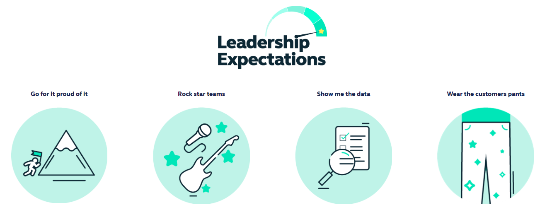
Health and access to healthcare have never been more important. With this comes endless exciting possibilities for innovation and growth. The market is evolving quickly, and we’re committed to leading-edge solutions our customers expect and deserve, now and for generations to come.

By reinventing ourselves, we will reach more customers, expand access to affordable healthcare, and unlock our growth potential. This next chapter is about transformational change.

To make this a reality, we will challenge our ways of working while keeping the customer at the heart of everything we do.
- This is an Andover based role, with a requirement to regularly attend meetings at our Hampshire based head-office but we have a ‘smart working’ policy with flexible remote working
- Some UK travel and overnight stays
- Reasonable role and task flexibility expected given the seniority of the role
- May be required to lead other business activities or projects in other parts of the Simplyhealth Group

