Head of Simplyhealth Funding Services (SFS)

Job Family: | Emerging Businesses | Line of Business: | Emerging Businesses
Reports to: | Corporate Finance Director | Team size: | c. 7
Our Purpose & Vision
For over 150 years, Simplyhealth has improved access to UK healthcare, long before the NHS existed. Today, as a certified B-Corp, we continue to modernise in ways that matter deeply to our c.2.5 million members, our customers, and our people.
Our purpose is simple and ambitious: to improve access to healthcare for all in the UK. Through affordable health and dental plans, we help people manage their everyday healthcare needs and live healthier lives.
We have ambitious plans to play a much broader role in UK healthcare as a health solutions provider, supporting the NHS through the provision of outpatient support. This will be achieved though expanding both our customer base and service offering, to ensure it has the greatest possible impact on access to healthcare in the UK.
Our vision
With growing pressure on the NHS, Simplyhealth’s products are more essential than ever. But our ambition goes further: we aim to democratise healthcare by making it more affordable and accessible for everyone in the UK
By 2030, Simplyhealth Group will be the UK’s most trusted health navigation and access marketplace that delivers easy to find, affordable services, including our own provision of primary care and financial products that measurably improves outcomes for employees, individuals and providers.

What we do

Simplyhealth is the UK’s leading healthplan provider. Its healthplans help customers claim cash back for everyday outpatient healthcare treatments carried out by dentists, opticians, physiotherapists, chiropractors, and many more. The plans increasingly also help individuals navigate a complex health care landscape and provide access to care through clinically validated healthcare partners.
Simplyhealth helps employers to improve the health and wellbeing of their employees through its My Health service which gives access to GP services, a 24/7 advice and counselling helpline and a wealth of health advice and information.
It is also the UK’s leading dental payment plan provider. Its Denplan payment plan was developed almost 40 years ago by dentists, for dentists, and continues to support dental customers in budgeting for preventative dental care and to avoid future problems. Denplan also provides an extensive range of support services to help dentists run and grow their practices.
As a company limited by guarantee with no shareholders, Simplyhealth reinvests its profits to benefit its customers and communities, now and in the future.
Our Group strategy
Simplyhealth Group is building the UK’s most trusted health access platform, one place to find, book and pay for care, with clear prices, quality you can trust, and optional, fair point-of-need payment options. We focus on what matters most: fast access, less friction, and measurably better outcomes. By 2030, our aim is to be the most trusted way to navigate and access care across the UK, strengthened by our own provision of primary care where it materially improves speed, experience and value. To help customers easily find and access the help they need we also see opportunities for far greater awareness raising and cross-selling across our lines of businesses.
For employers, we keep their workforce healthy, productive, and engaged by offering affordable, scalable healthcare solutions that reduce absenteeism, support mental health, and deliver measurable ROI by tracking retention, speed of access, and reduced absence.
For working adults using the platform, we aim to make healthcare feel simple again. From the first click, they see real options, real prices and clear next steps, and they can book and pay their way. Helping them take control of their health without the wait, confusion, or financial strain. We see capitation, insurance and financing in the context of our dental patients, all being available in a one-stop shop, offering a simple customer journey. It’s care that fits life, not the other way around.
Our strategy is focused on helping people to Find the care they need and Fund the care they need affordably so ultimately they can Flourish:
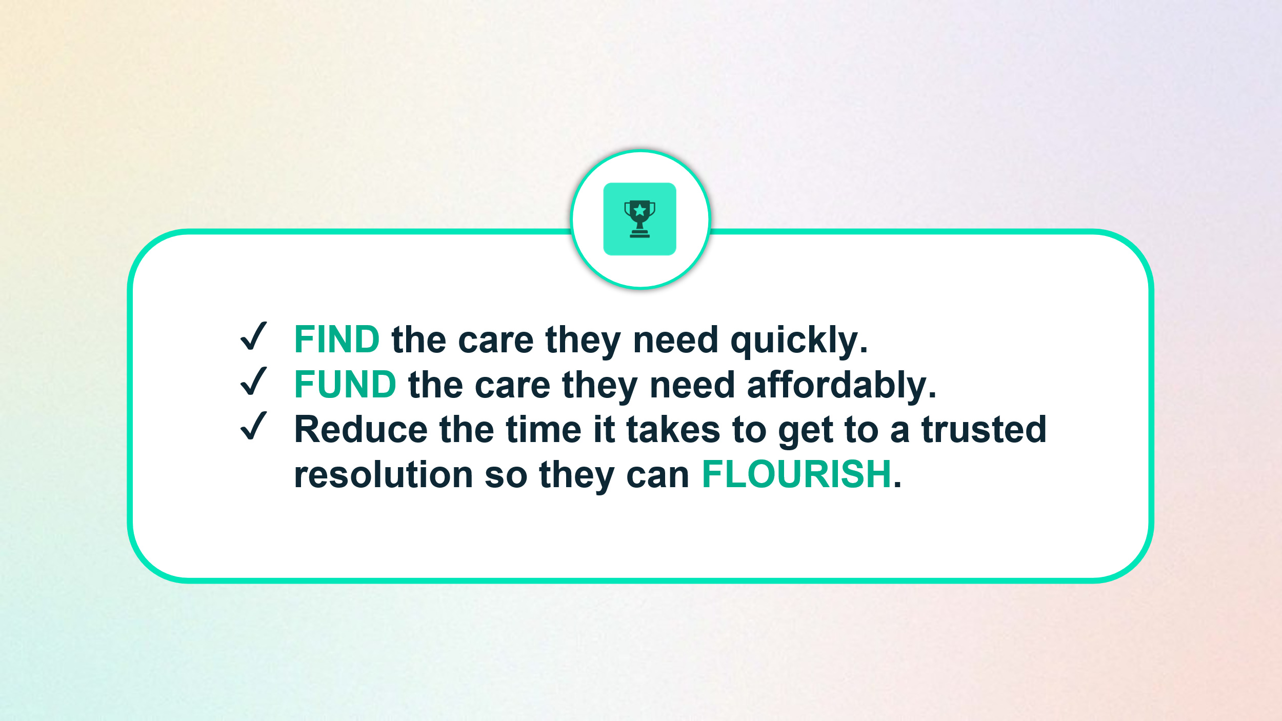

To achieve this, Simplyhealth has embarked on a radical transformation journey. With a trusted brand and a strong heritage in healthcare, it is uniquely placed to help change the landscape of healthcare in the UK.
The scale of this ambition and transformation is significant and requires energetic, ambitious, and digitally minded leaders to deliver against it.

Role Overview
The Head of SFS role essentially covers two key areas:

The primary area is to set, own and drive the strategic direction of Financing across the Simplyhealth Group. With it’s prevalence in the Group strategy, the Head of SFS will be responsible for delivering the Financing strategy and ensuring that it has full key stakeholder input and support, to build a £TBCm line of business within 5 years. This oversight will involve, but not be limited to; reviewing and recommending, if appropriate, alternative funding models, conducting test and learn activity on new thinking in Foundry, and identifying potential partner and acquisition opportunities to accelerate growth

The second area, following the recommendations set out in the Jan-26 Avyse external review, is to provide overall management and strategic direction of the SFS Operations team (formerly the Practi Operations team). This will initially include implementing all the relevant recommendations in the review and evolve to delivering enhanced processes and systems that ensure that the organisation is set up both operationally, and from a regulatory position, to accommodate increased volumes and the move into one or more new funding markets.

Key Responsibilities & Accountabilities:
Strategic Financing Delivery
- Own the relationship with any external credit providers (e.g Zopa) from both a strategic and day-to-day to maximise the outcomes for Simplyhealth.
- Provide expert input to Treatment Finance RFPs received in the Group, alongside the relevant LoB lead
- Understand the current and future regulations and provide commercial insight into the broad landscape of financial products and technologies ensuring that Simplyhealth minimises its risk exposure and maximises opportunities
- Build a clear picture of funding requirements across the Group, working with Healthplan and Denplan leadership, obtain ExCo and Board buy in, and start executing on this in H2 2026
- Build and own the 3YP growth model for financing within the Group with the aim of turning Funding into a £TBCm revenue stream within 5 years
- When appropriate authorisation is received, within Foundry, test out one of these requirements by building a link between Healthplan product and Zopa / another lender. Use learns to refine the product ready for mass market launch
- Complete a detailed market review of lenders and build a second / multi-panel of lenders model to de-risk reliance on a single credit provider and / or review alternate funding and distribution models (eg. Forward flow / partner network)
- Build the broader funding strategy to include, but not be limited to, looking at alternate models, looking at acquisition targets to boost funding reach and capability, looking at new financial products and markets

SFS Operational Management
- Overall management of the function, and ultimate responsibility for, the onboarding and due diligence of ARs and IARs to include:
  - All due diligence and assessments as to the fitness and priority of the I/AR; and
  - Any first line control, management information and other first line oversight activities relating to the conduct or position of I/ARs
- Oversight of process enhancements that will allow the SFS operations team to grow and support enhanced volumes and new areas of financing in the most efficient way
- Through the SFS Operations team, have ultimate responsibility for the management of customers to include management of customer complaints, management of issues relating to the Financial Ombudsman Service, and complaints about the dental practice itself
- Through the SFS Operations team, have full delegated responsibility from the relevant Senior Management Function for regulatory matters including (but not limited to) Consumer Duty reporting and monitoring, the SFS complaints framework, approval of financial promotions, SUP12 Annual Reports and SUP12 Self Assessments, and reviewing Anti-Money Laundering processes
- Work in partnership with the SFS / Compliance team to fully embed the findings of any external reviews, regulatory recommendations, or any assurance activities undertaken by compliance, internal audit or other assurance providers.
- Own and be fully responsible for Board reporting on operational and strategic progress, risks and opportunities to the SFS Board.
- Overall operational responsibility for the 1st line risk management and control environment of SFS for the matters set out above.
- The development, and ongoing adherence of, any key company policies and procedures to support the execution of the matters set out above.

Key Experience & Skills:
- Deep experience of the UK financing market including knowledge of legislation, key competitors, key opportunities
- Experience of driving and delivering digital innovation and delivering solutions
- Excellent stakeholder management and influencing skills
- Manages strategic programmes and projects to ensure delivery in time, quality and cost parameters
- An enthusing change agent with demonstrable experience shaping and delivering wide ranging portfolios of technology enabled change and transformation
- A strategic commercial thinker with gravitas and possesses the ability to make an impact
- Accountability - Clearly defines mutual expectations of self and others
- Business Acumen - Demonstrates awareness of internal and external dynamics, and an acute perception of the dimensions of business issues
- Decisiveness - Makes timely choices based on the options and information available
- Results Orientation - Sets and accomplishes challenging goals
- Team player – Leans in to offer insight, views and challenge to projects and initiatives managed by other team members
- Risk Taking - Handles changes and uncertainties with ease and with the ability to move forward quickly
- Experience of negotiating and delivering complex business deals
- Good interpersonal skills to build relationships with external Partners, and with other key internal functions
- Understanding of contractual terms and financial models
- Experience presenting to Executive Level

Our Culture and Values
We need to act with courage and curiosity to unlock opportunities for customers, colleagues, and communities. We operate with trust and kindness delivering what customers need and supporting colleagues to be their best. We live our All together healthier ethos, focusing on self-care and nurturing relationships.

Simplyhealth’s cultural ambition can be summarised as doing the right thing: by its customers, its people, its communities and our planet. It seeks individuals who have passion and energy, who believe in a commercial agenda but who also believe the outcome of Simplyhealth’s commercial endeavours can lead to a better life and a healthier planet.

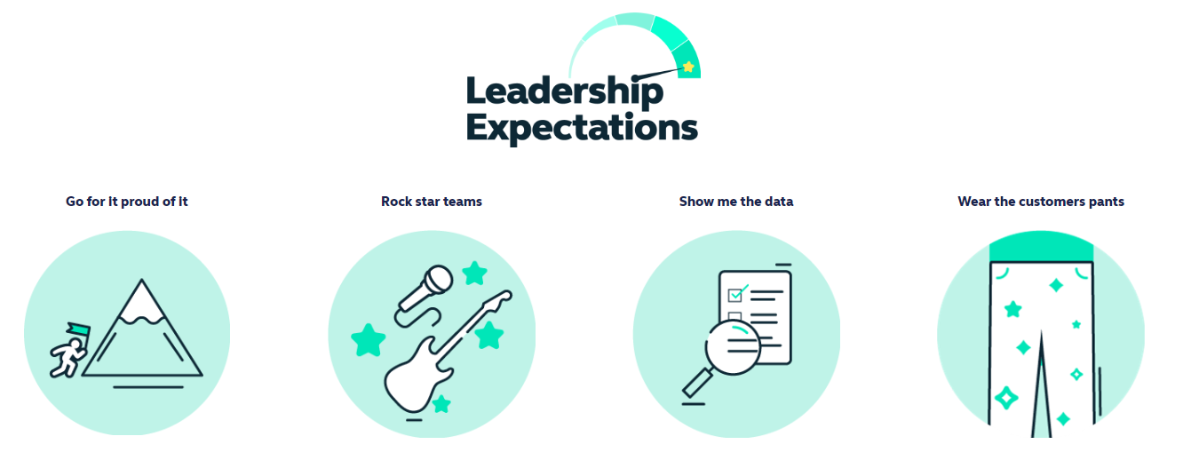
Health and access to healthcare have never been more important. With this comes endless exciting possibilities for innovation and growth. The market is evolving quickly, and we’re committed to leading-edge solutions our customers expect and deserve, now and for generations to come.

By reinventing ourselves, we will reach more customers, expand access to affordable healthcare, and unlock our growth potential. This next chapter is about transformational change.

To make this a reality, we will challenge our ways of working while keeping the customer at the heart of everything we do.
- This is an Andover based role, with a requirement to regularly attend meetings at our Hampshire based head-office but we have a ‘smart working’ policy with flexible remote working
- Some UK travel and overnight stays
- Reasonable role and task flexibility expected given the seniority of the role
- May be required to lead other business activities or projects in other parts of the Simplyhealth Group

