Head of Sales – Growth & Retention

Job Family: | Sales | Line of Business: | Health Plan
Reports to: | Sales & Marketing Director | Team size: | 8
Our Purpose & Vision
For over 150 years, Simplyhealth has improved access to UK healthcare, long before the NHS existed
Today, as a certified B-Corp, we continue to modernise in ways that matter deeply to our c.2.5 million members, our customers, and our people.

Our purpose is simple and ambitious: to improve access to healthcare for all in the UK
Through affordable health and dental plans, we help people manage their everyday healthcare needs and live healthier lives. With NHS pressures and the cost-of-living crisis making access to care harder, our mission is more critical than ever.
We have ambitious plans to play a much broader role in UK healthcare as a health solutions provider, supporting the NHS through the provision of outpatient support. This will be achieved though expanding both our customer base and service offering, to ensure it has the greatest possible impact on access to healthcare in the UK.

Our vision
With growing pressure on the NHS, Simplyhealth’s products are more essential than ever. But our ambition goes further: we aim to democratise healthcare by making it more affordable and accessible for everyone in the UK. By 2030, Simplyhealth Group will be the UK’s most trusted health navigation and access marketplace that delivers easy to find, affordable services, including our own provision of primary care and financial products that measurably improves outcomes for employees, individuals and providers.

What we do

Simplyhealth is the UK’s leading health plan provider. Its health plans help customers claim cash back for everyday outpatient healthcare treatments carried out by dentists, opticians, physiotherapists, chiropractors, and many more. The plans increasingly also help individuals navigate a complex health care landscape and provide access to care through clinically validated healthcare partners. Simplyhealth helps employers to improve the health and wellbeing of their employees through its My Health service which gives access to GP services, a 24/7 advice and counselling helpline and a wealth of health advice and information.

It is also the UK’s leading dental payment plan provider. Its Denplan payment plan was developed almost 40 years ago by dentists, for dentists, and continues to support dental customers in budgeting for preventative dental care and to avoid future problems. Denplan also provides an extensive range of support services to help dentists run and grow their practices.
As a company limited by guarantee with no shareholders, Simplyhealth reinvests its profits to benefit its customers and communities, now and in the future.

Our Group strategy
Simplyhealth Group is building the UK’s trusted health access platform, one place to find, book and pay for care, with clear prices, quality you can trust, and optional, fair point-of-need payment options. We focus on what matters most: fast access, less friction, and measurably better outcomes. By 2030, our aim is to be the most trusted way to navigate and access care across the UK, strengthened by our own provision of primary care where it materially improves speed, experience and value. To help customers easily find and access the help they need we also see opportunities for far greater awareness raising and cross-selling across our lines of businesses.

For employers, we keep their workforce healthy, productive, and engaged by offering affordable, scalable healthcare solutions that reduce absenteeism, support mental health, and deliver measurable ROI by tracking retention, speed of access, and reduced absence.

For working adults using the platform, we aim to make healthcare feel simple again. From the first click, they see real options, real prices and clear next steps, and they can book and pay their way. Helping them take control of their health without the wait, confusion, or financial strain. We see capitation, insurance and financing in the context of our dental patients, all being available in a one-stop shop offering a simple customer journey. It’s care that fits life, not the other way around.
Our strategy is focused on helping people to Find the care they need and Fund the care they need affordably so ultimately, they can Flourish
Role Overview
The Head of Sales – Growth & Retention (Healthplan) is accountable for leading the growth and retention strategy of a £126m existing book of business. The role owns the end-to-end go-to-market strategy across direct, broker and digital channels, driving sustainable revenue growth while maximising customer lifetime value. Working cross-functionally, the role is responsible for strengthening and evolving the Healthplan proposition, ensuring it remains competitive, differentiated and aligned to customer and market needs.

As Healthplan operates as a line of business within a wider product-led organisation, this role requires strong matrix leadership, collaborating closely with Product, Tech, Marketing, Pricing, Operations, Sales & Marketing Operations and the wider Marketing teams to ensure Healthplan’s commercial priorities are fully aligned to product roadmaps, digital capability development and customer experience improvements that position Simplyhealth as a trusted provider of affordable health solutions.

Based on the Healthplan business plan, the role is responsible for the delivery of agreed net membership growth, total revenue and retention outcomes, with shared responsibility for gross margin performance and accountable contribution, ensuring sustainable and profitable growth in line with Simplyhealth’s strategic ambition to improve access to healthcare across the UK.

Key Responsibilities & Accountabilities:
- Lead, inspire and develop the Healthplan Growth & Retention teams to deliver sustainable revenue growth, acquisition and retention performance across direct, broker and digital channels, aligned to Simplyhealth’s purpose of improving access to healthcare.
- Hold overall accountability for Healthplan commercial performance, including:
  - Retention of approximately 6,000 existing clients, representing a £126m book of business
  - Delivery of circa £3m in additional annual revenue through account expansion, upsell and cross-sell activity across the Healthplan portfolio
- Define and deliver the Healthplan go-to-market strategy, ensuring routes to market are effective, customer-focused and support long-term, profitable growth
- The role has executive ownership of the company’s largest account, ensuring retention, growth and long-term value.
- Drive organic growth across existing employer, SME and individual member portfolios, building strong, long-term relationships and supporting customers throughout their healthcare journey.
- Identify and convert opportunities to increase value for both customers and Simplyhealth through effective upsell and cross-sell activity across the Healthplan portfolio.
- Embed best-in-class sales and retention practices, underpinned by robust insight, high-quality MI, disciplined forecasting and transparent performance management.
- Leverage data and customer insight to understand customer behaviour, uncover growth and retention opportunities, and continuously improve acquisition and retention outcomes.
- Develop and deliver clear channel- and segment-level growth and retention plans that align with and support Simplyhealth’s wider strategic objectives and ambitions.
- Partner with the New Business leadership team to oversee strategic broker relationships, leading QBRs and presenting insightful MI, performance analysis and trend-based recommendations.
- Champion a strong culture of compliance, risk awareness and Consumer Duty, ensuring customers are treated fairly and outcomes are central to all commercial activity
- Communicate Healthplan priorities, progress and outcomes clearly and openly with senior leaders and key stakeholders
- Continuously look for ways to simplify, improve and modernise how the team works, increasing efficiency and speed while protecting quality and customer experience
- Operate effectively within a product-led, matrix organisation, working collaboratively with:
  - Product – to evolve the Healthplan proposition and align commercial priorities to product roadmaps
  - Tech – to improve digital journeys, onboarding, self-service and lifecycle experiences
  - Marketing – to align brand positioning, campaigns, acquisition and retention activity
  - Pricing & Finance – to shape fair, sustainable pricing and robust commercial plans
  - Operations– to ensure growth is delivered alongside a consistently positive customer experience
  - Sales & Marketing Operations – to embed tools, insight and ways of working that support performance

Key Experience & Skills:
- Proven experience operating at senior level in account management, with a consistent track record of managing complex, high-value accounts.
- Senior leadership experience in sales, growth or retention within healthcare, insurance or membership-based sectors
- Proven track record of delivering sustainable commercial growth and retention
- Experience working in a product-led, matrix environment
- Strong commercial, analytical and data-driven mindset
- Ability to lead, inspire and develop high-performing teams
- Strong stakeholder management and influencing skills

Our Culture and Values
We need to act with courage and curiosity to unlock opportunities for customers, colleagues, and communities. We operate with trust and kindness delivering what customers need and supporting colleagues to be their best. We live our All together healthier ethos, focusing on self-care and nurturing relationships.

Simplyhealth’s cultural ambition can be summarised as doing the right thing: by its customers, its people, its communities and our planet. It seeks individuals who have passion and energy, who believe in a commercial agenda but who also believe the outcome of Simplyhealth’s commercial endeavours can lead to a better life and a healthier planet.

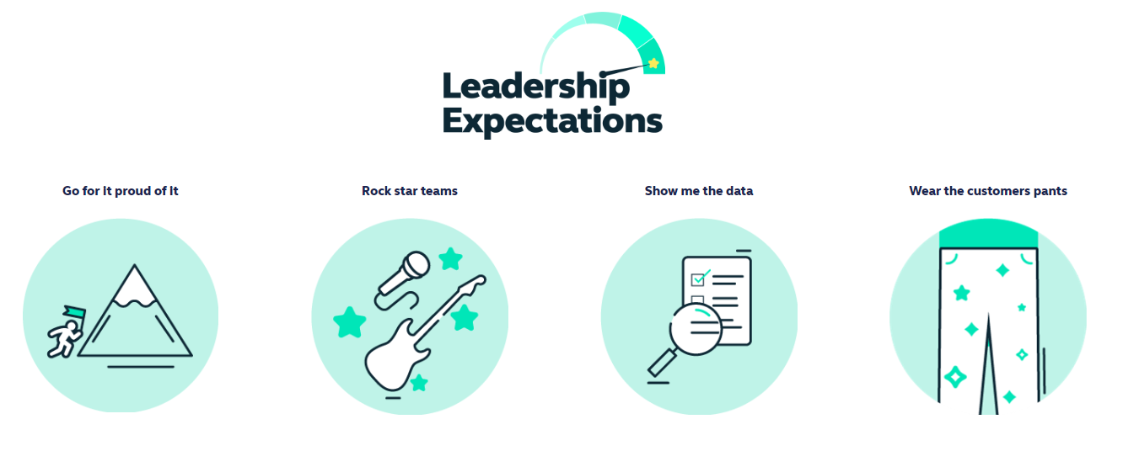
Health and access to healthcare have never been more important. With this comes endless exciting possibilities for innovation and growth. The market is evolving quickly, and we’re committed to leading-edge solutions our customers expect and deserve, now and for generations to come.

By reinventing ourselves, we will reach more customers, expand access to affordable healthcare, and unlock our growth potential. This next chapter is about transformational change.

To make this a reality, we will challenge our ways of working while keeping the customer at the heart of everything we do.
- This is an Andover based role, with a requirement to regularly attend meetings at our Hampshire based head-office but we have a ‘smart working’ policy with flexible remote working
- Some UK travel and overnight stays
- Reasonable role and task flexibility expected given the seniority of the role
- May be required to lead other business activities or projects in other parts of the Simplyhealth Group

