New Business Development Manager

Budget: | N/a | Function: | Denplan Sales & Marketing
Line Manager: | Head of Sales & Marketing - Denplan | Direct Reports: | 3
Our Vision
For over 150 years, Simplyhealth has improved access to UK healthcare, long before the NHS existed
Today, as a certified B-Corp, we continue to modernise in ways that matter deeply to our c.2.5 million members, our customers, and our people.

Our purpose is simple and ambitious: to improve access to healthcare for all in the UK
Through affordable health and dental plans, we help people manage their everyday healthcare needs and live healthier lives. With NHS pressures and the cost-of-living crisis making access to care harder, our mission is more critical than ever.
We have ambitious plans to play a much broader role in UK healthcare as a health solutions provider, supporting the NHS through the provision of outpatient support. This will be achieved though expanding both our customer base and service offering, to ensure it has the greatest possible impact on access to healthcare in the UK.

Our vision
With growing pressure on the NHS, Simplyhealth’s products are more essential than ever. But our ambition goes further: we aim to democratise healthcare by making it more affordable and accessible for everyone in the UK. By 2030, Simplyhealth Group will be the UK’s most trusted health navigation and access marketplace that delivers easy to find, affordable services, including our own provision of primary care and financial products that measurably improves outcomes for employees, individuals and providers.

What we do

Simplyhealth is the UK’s leading health plan provider. Its health plans help customers claim cash back for everyday outpatient healthcare treatments carried out by dentists, opticians, physiotherapists, chiropractors, and many more. The plans increasingly also help individuals navigate a complex health care landscape and provide access to care through clinically validated healthcare partners. Simplyhealth helps employers to improve the health and wellbeing of their employees through its My Health service which gives access to GP services, a 24/7 advice and counselling helpline and a wealth of health advice and information.

It is also the UK’s leading dental payment plan provider. Its Denplan payment plan was developed almost 40 years ago by dentists, for dentists, and continues to support dental customers in budgeting for preventative dental care and to avoid future problems. Denplan also provides an extensive range of support services to help dentists run and grow their practices.
As a company limited by guarantee with no shareholders, Simplyhealth reinvests its profits to benefit its customers and communities, now and in the future.

Our Group strategy
Simplyhealth Group is building the UK’s trusted health access platform, one place to find, book and pay for care, with clear prices, quality you can trust, and optional, fair point-of-need payment options. We focus on what matters most: fast access, less friction, and measurably better outcomes. By 2030, our aim is to be the most trusted way to navigate and access care across the UK, strengthened by our own provision of primary care where it materially improves speed, experience and value. To help customers easily find and access the help they need we also see opportunities for far greater awareness raising and cross-selling across our lines of businesses.

For employers, we keep their workforce healthy, productive, and engaged by offering affordable, scalable healthcare solutions that reduce absenteeism, support mental health, and deliver measurable ROI by tracking retention, speed of access, and reduced absence.

For working adults using the platform, we aim to make healthcare feel simple again. From the first click, they see real options, real prices and clear next steps, and they can book and pay their way. Helping them take control of their health without the wait, confusion, or financial strain. We see capitation, insurance and financing in the context of our dental patients, all being available in a one-stop shop, offering a simple customer journey. It’s care that fits life, not the other way around.

Our strategy is focused on helping people to Find the care they need and Fund the care they need affordably so ultimately, they can Flourish
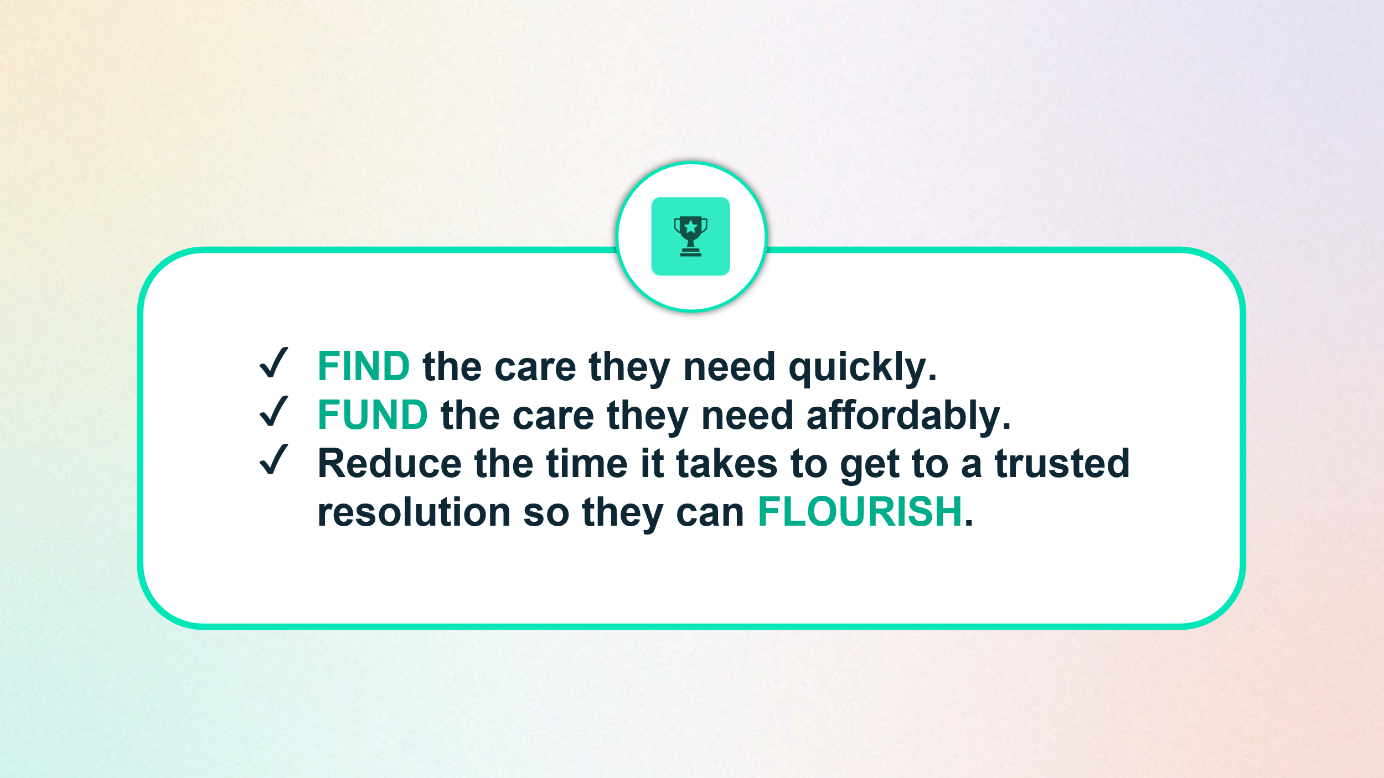
To achieve this, Simplyhealth has embarked on a radical transformation journey. With a trusted brand and a strong heritage in healthcare, it is uniquely placed to help change the landscape of healthcare in the UK. The scale of this ambition and transformation is significant and requires energetic, ambitious, and digitally minded leaders to deliver against it.

Your Role
As the New Business Development Manager for the Denplan line of business, your primary goal is growth through the identification and delivery of new business opportunities in the dental market across independent practices and groups.

You will shape the business development team and lead all aspects of business development liaising with marketing colleagues to ensure optimised full funnel new business activities are in place.

You will spearhead the development and execution of a targeted new business sales strategy focused on acquiring new clients for Denplan’s products.

You will lead new process development for upsell of products to existing customers, in conjunction with existing customer teams.
Your Responsibilities & Accountabilities:
- To identify emerging new business opportunities and market trends within the Dental sector to drive sales performance and expedite sustained revenue growth.
- Leverage technology and data to automate -where possible- the lead generation and lead nurture part of the sales funnel.
- Collaborate with Marketing, Product and other teams across the business as relevant, to align new business growth strategies with the overall company goals.
- Recruit and lead a highly effective new business sales team to achieve sales and value targets.
- Represent Simplyhealth at industry events and conferences, serving as a key advocate for the company within the Dental sector
- Actively lead a best practice culture around compliance & risk and consumer duty, working with Senior Managers as appropriate, ensuring adherence and knowledge of company policies and procedures.
- Ensure that all sales processes are in line with FCA requirements and monitored effectively
- In collaboration with the Head of Sales and Marketing, develop and implement strategic new business development plans for attracting and building new and long-term client relationships aligned with the company’s objectives and growth targets.
- Communicate growth plans, progress, and results to senior leadership and other stakeholders.
- Input into and influence the development of compelling value propositions and sales pitches tailored to different client segments.
- Work with the rest of the Denplan Sales and Marketing Leadership team to embed effective sales processes across the Denplan Sales Team.
- Lead the business development team in ensuring that all relevant information is passed on to the appropriate teams to effectively onboard and manage new clients.

Key Experience:
- Proven track record of driving significant growth through the acquisition of new B2B clients from sole traders through to corporate entities.
- Strong background in Dental industry or related industries, with a deep understanding of the dental market.
- Ability to effectively manage sales pipelines, forecast future opportunities, and develop sales plans aligned with strategic business objectives.
- A natural people leader with experience of building and developing high performing new business sales teams.

Our Values
Health and access to healthcare have never been more important. With this comes endless exciting possibilities for innovation and growth. The market is evolving quickly, so we need to ensure our customers have access to the leading-edge health solutions they expect and deserve, now and for generations to come.
We’re living in extraordinary times…

By reinventing ourselves, we will reach more customers, giving them increased access to affordable healthcare and unlocking our growth potential. This next chapter is about transformational change for us.

This is our time to survive, drive and thrive…
This is our chance to get ahead and stay ahead. We will ensure our commercial success by moving into new areas of healthcare, and leading with preventative, breakthrough solutions. We will use innovative digital tools, embracing technology to create new partnerships and opportunities. We are passionate about helping every generation lead better lives and get the care they need in real time.
To make this a reality, we need to challenge our ways of working, whilst keeping the customer at the heart of everything we do. To really make a difference, it’ll take every single one of us across Simplyhealth to step up.

Our cultural movement...

To act with courage and curiosity, so we can unlock the opportunities to help customers, colleagues and communities. To operate with trust and kindness, working alongside customers, delivering what they need to live their best lives, as well as supporting colleagues as they strive to be their best. Spotlight our passion for All together healthier, focusing on self-care and nurturing relationships. We must ensure we are a strong team - one that’s able to build healthier lives for all. We each have an important role to play in this next chapter. Everyone has the freedom to innovate and make a difference for our customers. We need to act at pace and take on newer, braver, creative approaches. We shouldn’t be afraid to fail fast and learn quickly. By being curious and continually pushing ourselves and each other, we will find new and better ways.

Our Behaviours
Courage and Curiosity | Trust and Kindness | All Together Healthier
So we deliver profits for a purpose | Because our customers, colleagues and communities are at the heart of what we do | Enabling better health outcomes together
- We make bold decisions and take considered risks, with customer and commerciality front of mind.  - We make things happen and keep things simple.  - We always take the initiative and hold ourselves accountable for the delivery of great results.  - We ask questions and listen intently as every viewpoint and capability counts, and we have the courage to be honest and say what we think. | - We invest in relationships to build trust and rapport.  - We listen carefully always trying to find ways to add value.  - We treat each other with care, compassion and kindness, celebrating and embracing differences.  - We strive to make a difference in society, unlocking opportunities for those in need. | - We help every generation take control of their health.  - We start with self-care so we can show up at our best, every day.  - We are full of energy and pride in what we do. We focus on self-development to learn and grow, so we can stay up to date and add value.  - We innovate and collaborate on our best ideas. Together, we can drive the changes that are needed to help our business grow, and help our customers live their best lives.

- The role is a field based role, with the requirement to operate in line with our SMART Working Guidance.
- Regular attendance at client sites.
- Regular attendance at Leadership meetings and events.
- UK travel & overnight stays.
- Reasonable role and task flexibility expected given the seniority of the role.
- May be required to lead other business activities or projects in other parts of the Simplyhealth Group.

