Head of Internal Audit

Budget: | TBC | Function: | Groupwide responsibility for Internal Audit.
Line Manager: | Direct line to the Chair of the Audit Committee  Dotted line to the CRO | Direct Reports: | 2 direct report + management of external co-source
Our Purpose and Vision
For over 150 years, Simplyhealth has improved access to UK healthcare, long before the NHS existed. Today, as a certified B-Corp, we continue to modernise in ways that matter deeply to our c.2.5 million members, our customers, and our people.
Our purpose is simple and ambitious: to improve access to healthcare for all in the UK. Through affordable health and dental plans, we help people manage their everyday healthcare needs and live healthier lives.
We have ambitious plans to play a much broader role in UK healthcare as a health solutions provider, supporting the NHS through the provision of outpatient support. This will be achieved though expanding both our customer base and service offering, to ensure it has the greatest possible impact on access to healthcare in the UK.
Our vision
With growing pressure on the NHS, Simplyhealth’s products are more essential than ever. But our ambition goes further: we aim to democratise healthcare by making it more affordable and accessible for everyone in the UK
By 2030, Simplyhealth Group will be the UK’s most trusted health navigation and access marketplace that delivers easy to find, affordable services, including our own provision of primary care and financial products that measurably improves outcomes for employees, individuals and providers.

What we do

Simplyhealth is the UK’s leading health plan provider. Its health plans help customers claim cash back for everyday outpatient healthcare treatments carried out by dentists, opticians, physiotherapists, chiropractors, and many more. The plans increasingly also help individuals navigate a complex health care landscape and provide access to care through clinically validated healthcare partners.
Simplyhealth helps employers to improve the health and wellbeing of their employees through its My Health service which gives access to GP services, a 24/7 advice and counselling helpline and a wealth of health advice and information.
It is also the UK’s leading dental payment plan provider. Its Denplan payment plan was developed almost 40 years ago by dentists, for dentists, and continues to support dental customers in budgeting for preventative dental care and to avoid future problems. Denplan also provides an extensive range of support services to help dentists run and grow their practices.
As a company limited by guarantee with no shareholders, Simplyhealth reinvests its profits to benefit its customers and communities, now and in the future.

Our Group strategy
Simplyhealth Group is building the UK’s trusted health access platform, one place to find, book and pay for care, with clear prices, quality you can trust, and optional, fair point-of-need payment options. We focus on what matters most: fast access, less friction, and measurably better outcomes. By 2030, our aim is to be the most trusted way to navigate and access care across the UK, strengthened by our own provision of primary care where it materially improves speed, experience and value. To help customers easily find and access the help they need we also see opportunities for far greater awareness raising and cross-selling across our lines of businesses.
For employers, we keep their workforce healthy, productive, and engaged by offering affordable, scalable healthcare solutions that reduce absenteeism, support mental health, and deliver measurable ROI by tracking retention, speed of access, and reduced absence.
For working adults using the platform, we aim to make healthcare feel simple again. From the first click, they see real options, real prices and clear next steps, and they can book and pay their way. Helping them take control of their health without the wait, confusion, or financial strain. We see capitation, insurance and financing in the context of our dental patients, all being available in a one-stop shop, offering a simple customer journey. It’s care that fits life, not the other way around.
Our strategy is focused on helping people to Find the care they need and Fund the care they need affordably so ultimately they can Flourish:
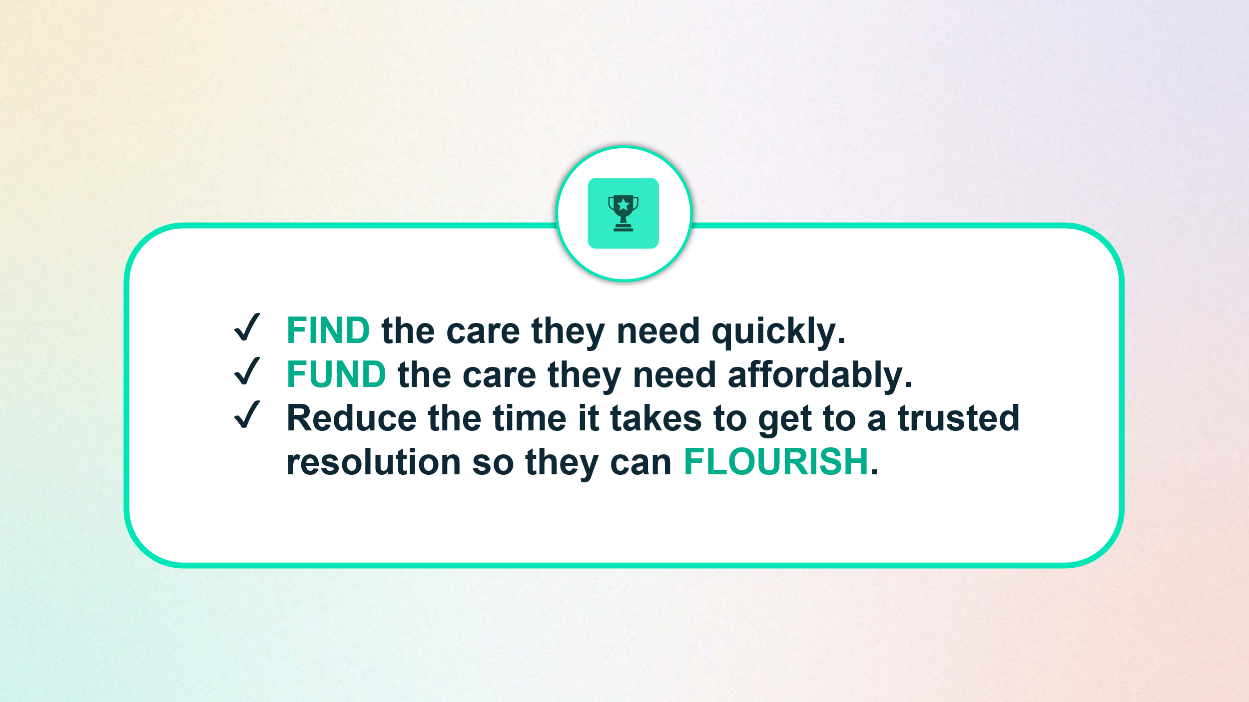
To achieve this, Simplyhealth has embarked on a radical transformation journey. With a trusted brand and a strong heritage in healthcare, it is uniquely placed to help change the landscape of healthcare in the UK.
The scale of this ambition and transformation is significant and requires energetic, ambitious, and digitally minded leaders to deliver against it.
Your Role
The Head of Internal Audit will be responsible for designing and delivering the audit strategy and plan to effectively support the strategic objectives of Simplyhealth.
Reporting to the Chair of the Audit Committee with a dotted line to the Chief Risk Officer, the Internal Audit Function provides assurance that the organisation is effectively delivering on its strategic plan and has effective governance and controls in place to ensure the strategic plan is delivered in line with risk appetite.
Working with a small internal team supplemented with co-sourced skills from an external 3rd party, the Head of Internal Audit will be a respected and trusted advisor to the Chair of the Audit Committee and the Board, providing expert advice to support their oversight of the business.
As Head of Internal Audit the candidate is critical to helping the continued development of the high-performance culture that is aligned to the aspirations of the Simplyhealth group. This is a ‘hands-on’ role, whereby the candidate will be balancing strategic decision making, senior stakeholder management, leadership and team development, managing the 3rd party relations and co-source activity and well as leading individual audits when required.

Your Responsibilities & Accountabilities:
- Accountable for the development, delivery and execution of the three year Internal Audit strategy and the risk based Annual Internal Audit Plan, in line with the International Professional Practices Framework.
- Works closely with leaders across Risk and Assurance to develop and execute a Joint Assurance Plan.
- Develop and manage the resource plan to deliver the audit programme, in line with Audit Committee expectations. This includes responsibility for the management and utilisation of external co-source budget.
- Oversees the delivery of the annual plan across group including central support functions (Finance, Legal, Compliance, HR), IT and group operational areas.
- Accountable for the development of the Internal Audit function and, as a key leadership role within Simplyhealth, helping to develop and embed the wider risk culture across the organisation.
- Responsible for reporting progress updates and team performance KPI’s to the Audit Committee on a quarterly basis, along with clear, insightful audit findings. This will include providing high quality written and verbal updates to the Audit Committee and senior stakeholders.
- Accountable for providing an annual Head of Internal Audit Opinion, to the Audit Committee.
- Lead the development and use of data analytics within Internal Audit.
- Maintain and oversee a Quality Assurance and Improvement Program to ensure continuous improvement and professional compliance.
- Work closely with External Audit to support statutory audit activity as required.
- Serve as a trusted advisor to executive leadership and the Board Risk Committee on governance, risk management and internal control matters.
- Identify audit themes and emerging risks, providing insights to both the Executive Team and Board.
This is a senior management role – PRA, Senior Management Function SMF5 and as such the preferred candidate will require regulatory approval.

Key Experience & Ski:
- Previous experience as a Head of / Deputy Head of Internal Audit, with a proven track record of delivering a risk based, comprehensive and flexible audit plans to assess, report on and make suggestions for improving key operational and financial controls.
- Previous experience of working with, and presenting to, Audit Committees and/or Boards or other Board level committees.
- Significant experience of managing the end to end audit life-cycle, including conducting audit investigations, assurance work and root cause analysis to identify underlying themes.
- Effective at cultivating relationships with management at all levels to promote a culture of risk awareness and sound internal control.
- A sound knowledge of the UK regulatory environment.
- Strong personal credibility, adept in influencing and with sharp judgement.
- Strong leadership skills including championing personal development.

Our Culture and Values
We need to act with courage and curiosity to unlock opportunities for customers, colleagues, and communities. We operate with trust and kindness delivering what customers need and supporting colleagues to be their best. We live our All together healthier ethos, focusing on self-care and nurturing relationships.

Simplyhealth’s cultural ambition can be summarised as doing the right thing: by its customers, its people, its communities and our planet. It seeks individuals who have passion and energy, who believe in a commercial agenda but who also believe the outcome of Simplyhealth’s commercial endeavours can lead to a better life and a healthier planet.
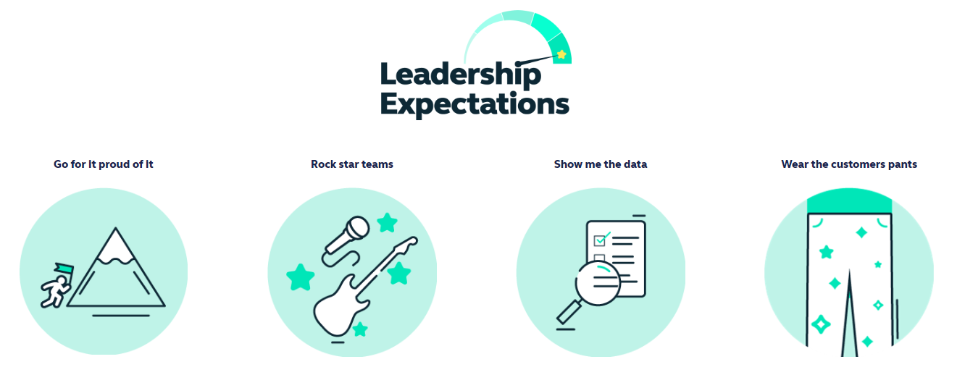
Health and access to healthcare have never been more important. With this comes endless exciting possibilities for innovation and growth. The market is evolving quickly, and we’re committed to leading-edge solutions our customers expect and deserve, now and for generations to come.

By reinventing ourselves, we will reach more customers, expand access to affordable healthcare, and unlock our growth potential. This next chapter is about transformational change.

To make this a reality, we will challenge our ways of working while keeping the customer at the heart of everything we do.
Work Arrangements
- This is a ‘hands-on’ role whereby the individual will be required to balance delivery of the audit plan with wider leadership responsibilities.
- This is an Andover based role, with a requirement to regularly attend meetings at our Hampshire based head-office but we have a ‘smart working’ policy with flexible remote working
- Reasonable role and task flexibility expected given the seniority of the role.
- Must be independent and demonstrate the strength of character to remain so.

