Customer Service Associate - SFS

Budget: | N/a | Function: | Simplyhealth Funding Services - SFS
Reports to: | Operations Manager - SFS | Direct Reports: | N/a
Our Purpose
For over 150 years, Simplyhealth has improved access to UK healthcare, long before the NHS existed
Today, as a certified B-Corp, we continue to modernise in ways that matter deeply to our c.2.5 million members, our customers, and our people.

Our purpose is simple and ambitious: to improve access to healthcare for all in the UK
Through affordable health and dental plans, we help people manage their everyday healthcare needs and live healthier lives. With NHS pressures and the cost of living crisis making access to care harder, our mission is more critical than ever.-of-living crisis making access to care harder, our mission is more critical than ever.
We have ambitious plans to play a much broader role in UK healthcare as a health solutions provider, supporting the NHS through the provision of outpatient support. This will be achieved though expanding both our customer base and service offering, to ensure it has the greatest possible impact on access to healthcare in the UK.

Our vision
With growing pressure on the NHS, Simplyhealth’s products are more essential than ever. But our ambition goes further: we aim to democratise healthcare by making it more affordable and accessible for everyone in the UK. By 2030, Simplyhealth Group will be the UK’s most trusted health navigation and access marketplace that delivers easy to find, affordable services, including our own provision of primary care and financial products that measurably improves outcomes for employees, individuals and providers.

What we do

Simplyhealth is the UK’s leading health plan provider. Its health plans help customers claim cash back for everyday outpatient healthcare treatments carried out by dentists, opticians, physiotherapists, chiropractors, and many more. The plans increasingly also help individuals navigate a complex health care landscape and provide access to care through clinically validated healthcare partners. Simplyhealth helps employers to improve the health and wellbeing of their employees through its My Health service which gives access to GP services, a 24/7 advice and counselling helpline and a wealth of health advice and information.

It is also the UK’s leading dental payment plan provider. Its Denplan payment plan was developed almost 40 years ago by dentists, for dentists, and continues to support dental customers in budgeting for preventative dental care and to avoid future problems. Denplan also provides an extensive range of support services to help dentists run and grow their practices.
As a company limited by guarantee with no shareholders, Simplyhealth reinvests its profits to benefit its customers and communities, now and in the future.

Our Group strategy
Simplyhealth Group is building the UK’s trusted health access platform, one place to find, book and pay for care, with clear prices, quality you can trust, and optional, fair point-of-need payment options. We focus on what matters most: fast access, less friction, and measurably better outcomes. By 2030, our aim is to be the most trusted way to navigate and access care across the UK, strengthened by our own provision of primary care where it materially improves speed, experience and value. To help customers easily find and access the help they need we also see opportunities for far greater awareness raising and cross-selling across our lines of businesses.

For employers, we keep their workforce healthy, productive, and engaged by offering affordable, scalable healthcare solutions that reduce absenteeism, support mental health, and deliver measurable ROI by tracking retention, speed of access, and reduced absence.

For working adults using the platform, we aim to make healthcare feel simple again. From the first click, they see real options, real prices and clear next steps, and they can book and pay their way. Helping them take control of their health without the wait, confusion, or financial strain. We see capitation, insurance and financing in the context of our dental patients, all being available in a one-stop shop, offering a simple customer journey. It’s care that fits life, not the other way around.

Our strategy is focused on helping people to Find the care they need and Fund the care they need affordably so ultimately, they can Flourish
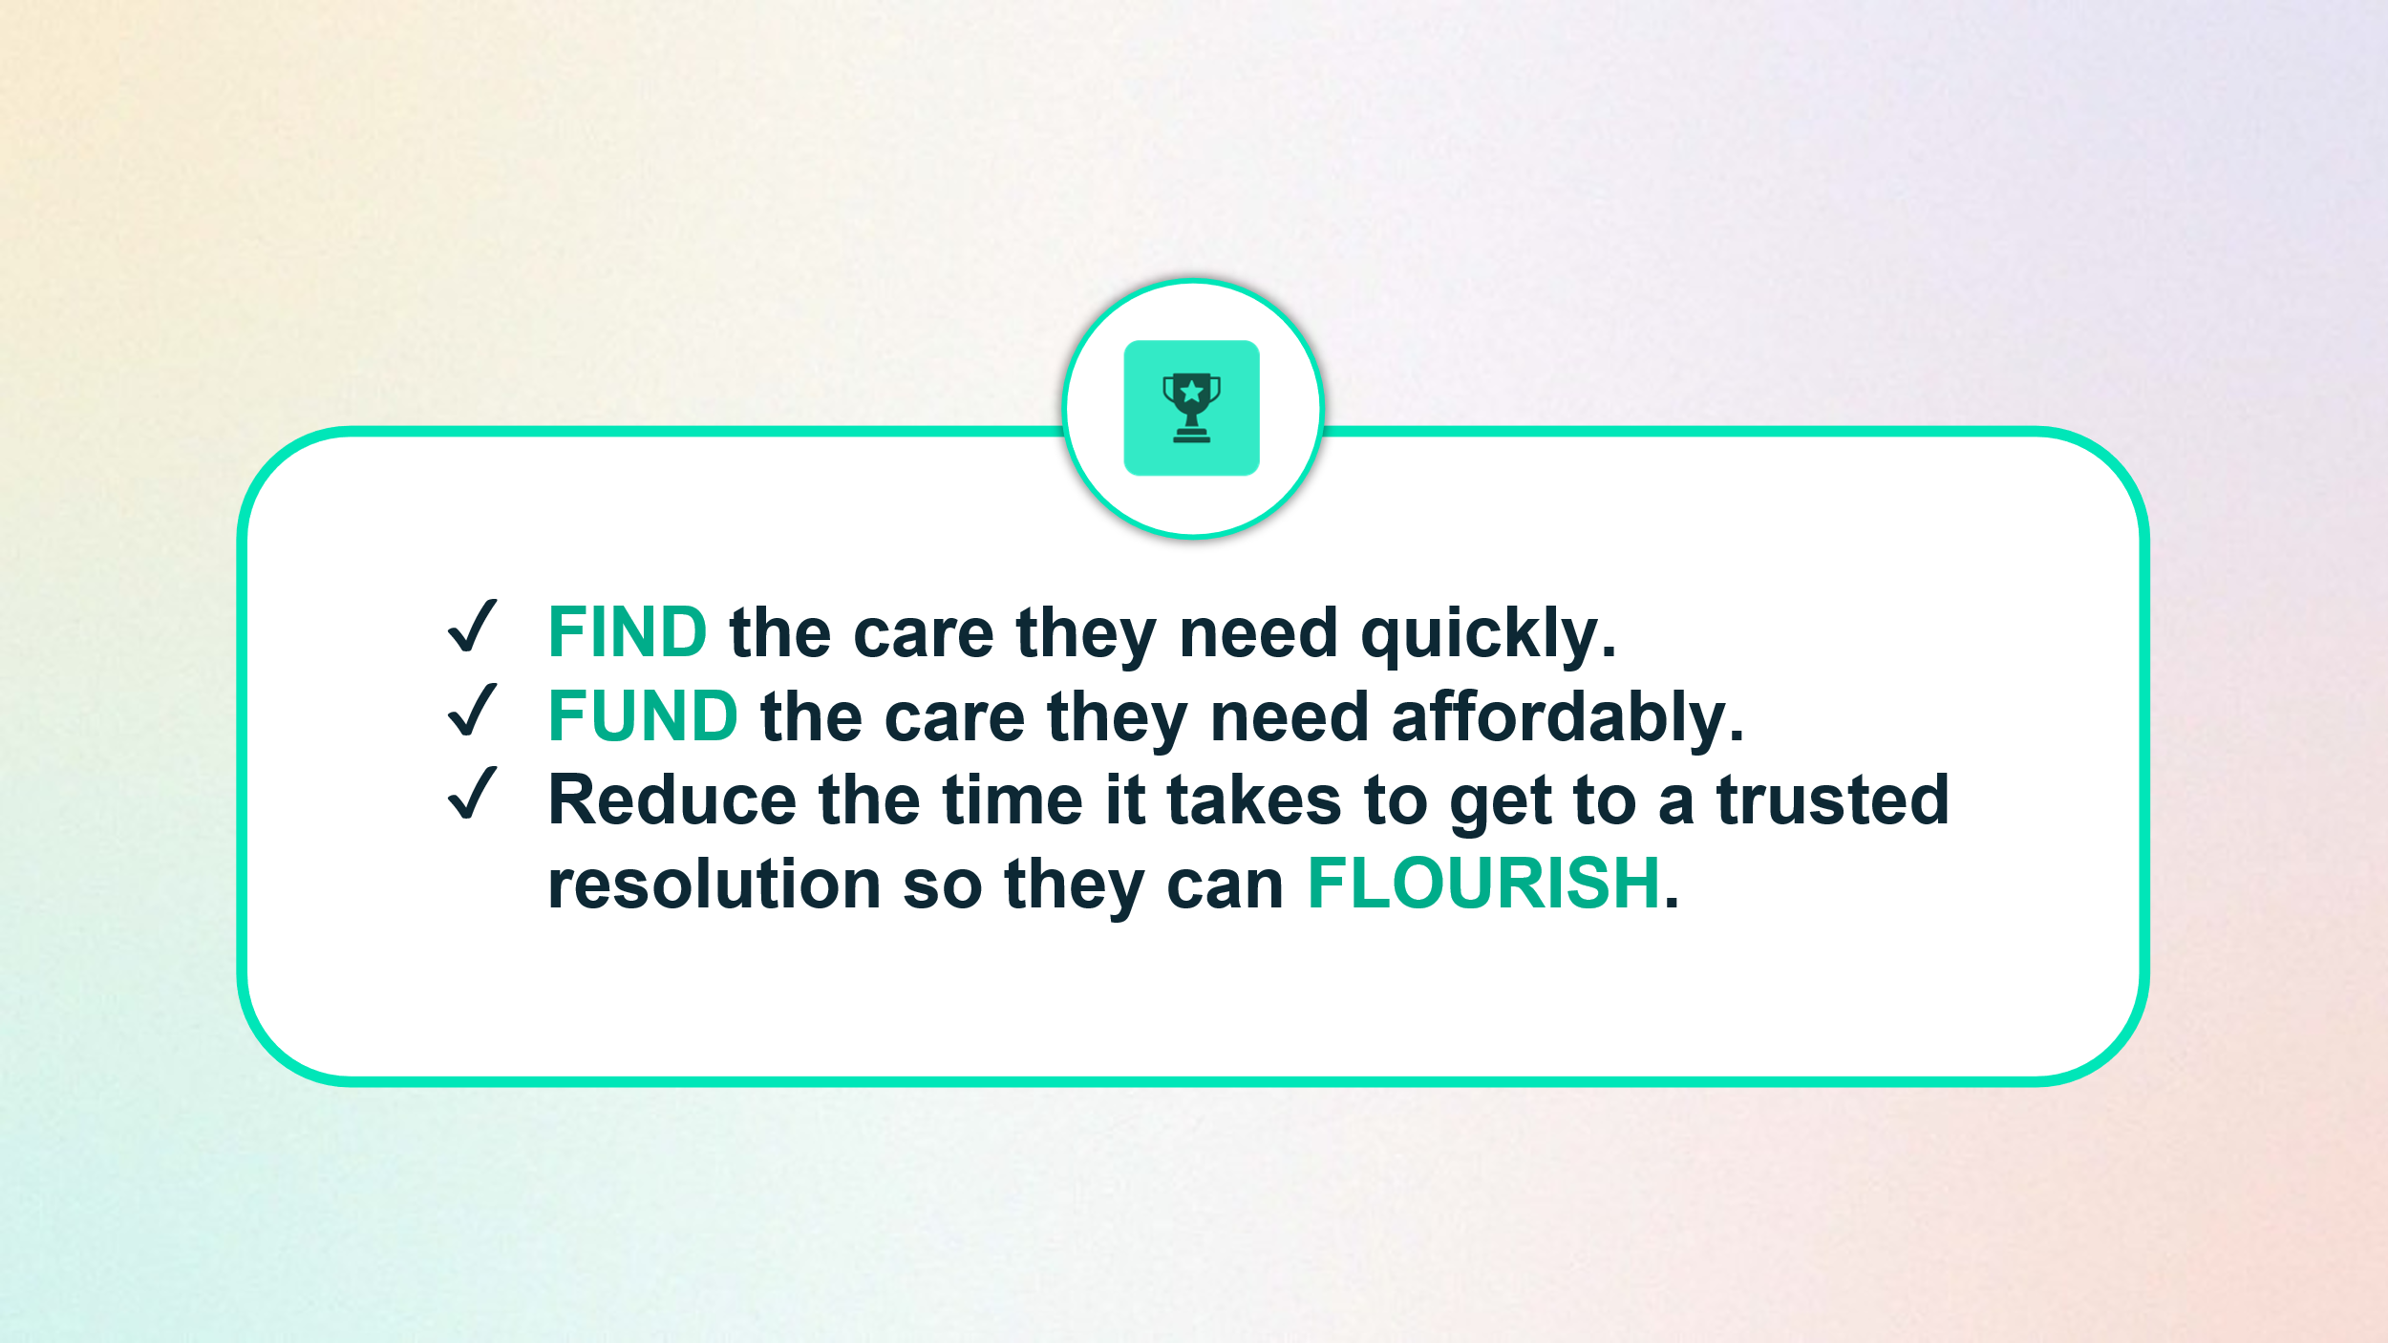
To achieve this, Simplyhealth has embarked on a radical transformation journey. With a trusted brand and a strong heritage in healthcare, it is uniquely placed to help change the landscape of healthcare in the UK. The scale of this ambition and transformation is significant and requires energetic, ambitious, and digitally minded leaders to deliver against it.

The Role
The Customer Service Associate (SFS) plays a key role in delivering a high quality, proactive and solutions focused support experience for dental practices and their patients using Simplyhealth Funding Services.
This role acts as the front line of customer support, ensuring enquiries, complaints, and operational issues are resolved efficiently and empathetically. Working closely with internal teams and external partners, this role helps shape a new customer service capability for SFS while supporting the continuous improvement of our products, processes, and customer outcomes.

Your Responsibilities & Accountabilities:
Resolution of a variety of customer enquiries
- Act as a first point of contact for customer and dental practice queries.
- Ensure that this is carried out efficiently for dental practices and their patients, and work closely with our internal teams and business partners to find solutions to the most frequent and impactful problems
- Provide clear, professional and timely responses to customers and practices in line with service level agreements (SLAs).
- Build and maintain positive working relationships with customers, dental practices and internal stakeholders.

Handle customer complaints
- Manage and resolve customer complaints, escalating complex or risk related issues to the SFS Operations Manager as needed to support the ongoing monitoring of dental practices to ensure adherence to required standards and processes, working closely with Risk & Compliance teams.

Drive process improvements
- Identify recurring themes and contribute to process improvement by sharing data-driven insights to enhance workflow efficiency and customer experience
- Support continuous improvement initiatives across SFS, including participation in training and development to maintain high compliance and service standards.

Case Management & Systems Expertise
- Accurately log, update and maintain all customer interactions within CRM and case management systems to ensure audit-ready, compliant records.
- Use systems effectively to track case progression, manage customer follow-ups, and ensure timely resolution of open queries.
- Capture complete and accurate data in line with operational, compliance and reporting requirements.
- Identify opportunities to improve processes or system workflows based on recurring patterns or user feedback.

Collaborate with stakeholders, product and engineering teams
- Work across a broad range of stakeholders to keep everyone aligned on customer needs and issues that will in turn shape product development and wider business development

Objective 1: Deliver a high-quality, responsive customer and practice support experience.
- Respond to at least 95% of customer and dental practice enquiries within agreed SLA each month.
- Achieve an average customer/practice satisfaction score of XX or higher for handled interactions.
Objective 2: Manage complaints and risk-related issues effectively and compliantly.
- Log 100% of onboarding complaints within one working day and resolve/final response sent 100% within FCA required timeframes.
- Provide requested evidence for 100% of escalated complaints within agreed deadlines.
Objective 3: Maintain accurate, audit-ready case management and customer records.
- Maintain at least 98% accuracy and completeness across CRM and case management records based on monthly quality checks.
- Ensure 100% of open cases have clear ownership, next action and follow-up date recorded.
- Complete all required case updates within one working day of customer, practice or stakeholder contact.
Objective 4: Contribute to continuous improvement across SFS service operations.
- Identify and share at least 3 recurring customer, practice, complaint or system themes each quarter with the SFS Operations Manager.
- Support delivery of at least 2 agreed process improvements per quarter that reduce repeat contact, improve workflow efficiency or improve customer outcomes.
- Complete 100% of mandatory training on time.
Objective 5: Strengthen collaboration with internal stakeholders and business partners.
- Attend and contribute to relevant service, operational or improvement meetings where input is required.
- Ensure 100% of agreed stakeholder actions are tracked and updated by the committed deadline or proactively re-planned where dependencies change.
Key Connections:
- SFS Team
- Denplan Sales & Marketing
- Denplan Operations
- Simplyhealth Risk & Compliance Teams
- Simplyhealth Service Teams
Key Experience & Skills:
Essential
- Experience in a customer service or operations role (financial services, healthcare or regulated environment desirable).
- Strong communication skills, both written and verbal.
- High attention to detail and accuracy.
- Ability to manage multiple tasks and prioritise workload effectively.
- Customer-focused mindset with a commitment to delivering good outcomes.
- Comfortable working with policies, procedures and regulatory requirements.

Desirable
- Experience handling complaints
- Knowledge of a regulated service environment
- Experience managing and resolving complex customer problems
- Strong IT and systems skills (CRM / case management systems).

Our Culture and Values
We need to act with courage and curiosity to unlock opportunities for customers, colleagues, and communities. We operate with trust and kindness delivering what customers need and supporting colleagues to be their best. We live our All together healthier ethos, focusing on self-care and nurturing relationships.

Simplyhealth’s cultural ambition can be summarised as doing the right thing: by its customers, its people, its communities and our planet. It seeks individuals who have passion and energy, who believe in a commercial agenda but who also believe the outcome of Simplyhealth’s commercial endeavours can lead to a better life and a healthier planet.

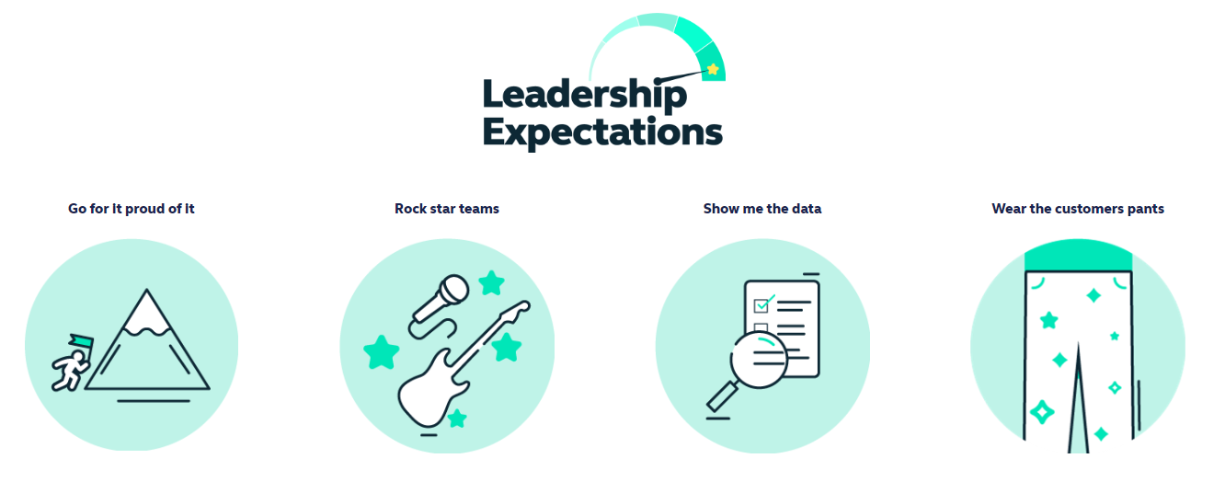

Health and access to healthcare have never been more important. With this comes endless exciting possibilities for innovation and growth. The market is evolving quickly, and we’re committed to leading-edge solutions our customers expect and deserve, now and for generations to come.

By reinventing ourselves, we will reach more customers, expand access to affordable healthcare, and unlock our growth potential. This next chapter is about transformational change. To make this a reality, we will challenge our ways of working while keeping the customer at the heart of everything we do.
- This is an Andover based role, with a requirement to regularly attend meetings at our Hampshire based head-office but we have a ‘smart working’ policy with flexible remote working
- Reasonable role and task flexibility expected

