Managing Director Denplan

Revenue: | c£35m | Line of Business: | Denplan
Reports to: | CEO | Team size: | Circa 70 (Sales, Marketing, Product, Clinical, Partnerships), plus matrix support from Engineering, Customer Service, Finance, People, Legal and Risk and Compliance.
Our Purpose & Vision
For over 150 years, Simplyhealth has improved access to UK healthcare, long before the NHS existed. Today, as a certified B-Corp, we continue to modernise in ways that matter deeply to our c.2.5 million members, our customers, and our people.
Our purpose is simple and ambitious: to improve access to healthcare for all in the UK. Through affordable health and dental plans, we help people manage their everyday healthcare needs and live healthier lives. With NHS pressures and the cost-of-living crisis making access to care harder, our mission is more critical than ever.
We have ambitious plans to play a much broader role in UK healthcare as a health solutions provider, supporting the NHS through the provision of outpatient support. This will be achieved though expanding both our customer base and service offering, to ensure it has the greatest possible impact on access to healthcare in the UK.

Our vision
With growing pressure on the NHS, Simplyhealth’s products are more essential than ever. But our ambition goes further: we aim to democratise healthcare by making it more affordable and accessible for everyone in the UK
By 2030, Simplyhealth Group will be the UK’s most trusted health navigation and access marketplace that delivers easy to find, affordable services, including our own provision of primary care and financial products that measurably improves outcomes for employees, individuals and providers.

What we do

Simplyhealth is the UK’s leading dental payment plan provider. Its Denplan payment plan was developed almost 40 years ago by dentists, for dentists, and continues to support dental customers in budgeting for preventative dental care and to avoid future problems. Denplan also provides an extensive range of support services to help dentists run and grow their practices. The business’ core offering covers almost 1.5 patients, transferring over £500m from patients to providers each year.

The Simplyhealth Group is also the UK’s leading health plan provider. Its health plans help customers claim cash back for everyday outpatient healthcare treatments carried out by dentists, opticians, physiotherapists, chiropractors, and many more. The plans increasingly also help individuals navigate a complex health care landscape and provide access to care through clinically validated healthcare partners.
Simplyhealth helps employers to improve the health and wellbeing of their employees through its My Health service which gives access to GP services, a 24/7 advice and counselling helpline and a wealth of health advice and information.
As a company limited by guarantee with no shareholders, Simplyhealth reinvests its profits to benefit its customers and communities, now and in the future.
Our Group strategy
Simplyhealth Group is building the UK’s trusted health access platform, one place to find, book and pay for care, with clear prices, quality you can trust, and optional, fair point-of-need payment options. We focus on what matters most: fast access, less friction, and measurably better outcomes. By 2030, our aim is to be the most trusted way to navigate and access care across the UK, strengthened by our own provision of primary care where it materially improves speed, experience and value. To help customers easily find and access the help they need we also see opportunities for far greater awareness raising and cross selling across our lines of businesses.
For employers, we keep their workforce healthy, productive, and engaged by offering affordable, scalable healthcare solutions that reduce absenteeism, support mental health, and deliver measurable ROI by tracking retention, speed of access, and reduced absence.
For working adults using the platform, we aim to make healthcare feel simple again. From the first click, they see real options, real prices and clear next steps, and they can book and pay their way. Helping them take control of their health without the wait, confusion, or financial strain. We see capitation, insurance and financing in the context of our dental patients, all being available in a one-stop shop, offering a simple customer journey. It’s care that fits life, not the other way around.

Our strategy is focused on helping people to Find the care they need and Fund the care they need affordably so ultimately they can Flourish:
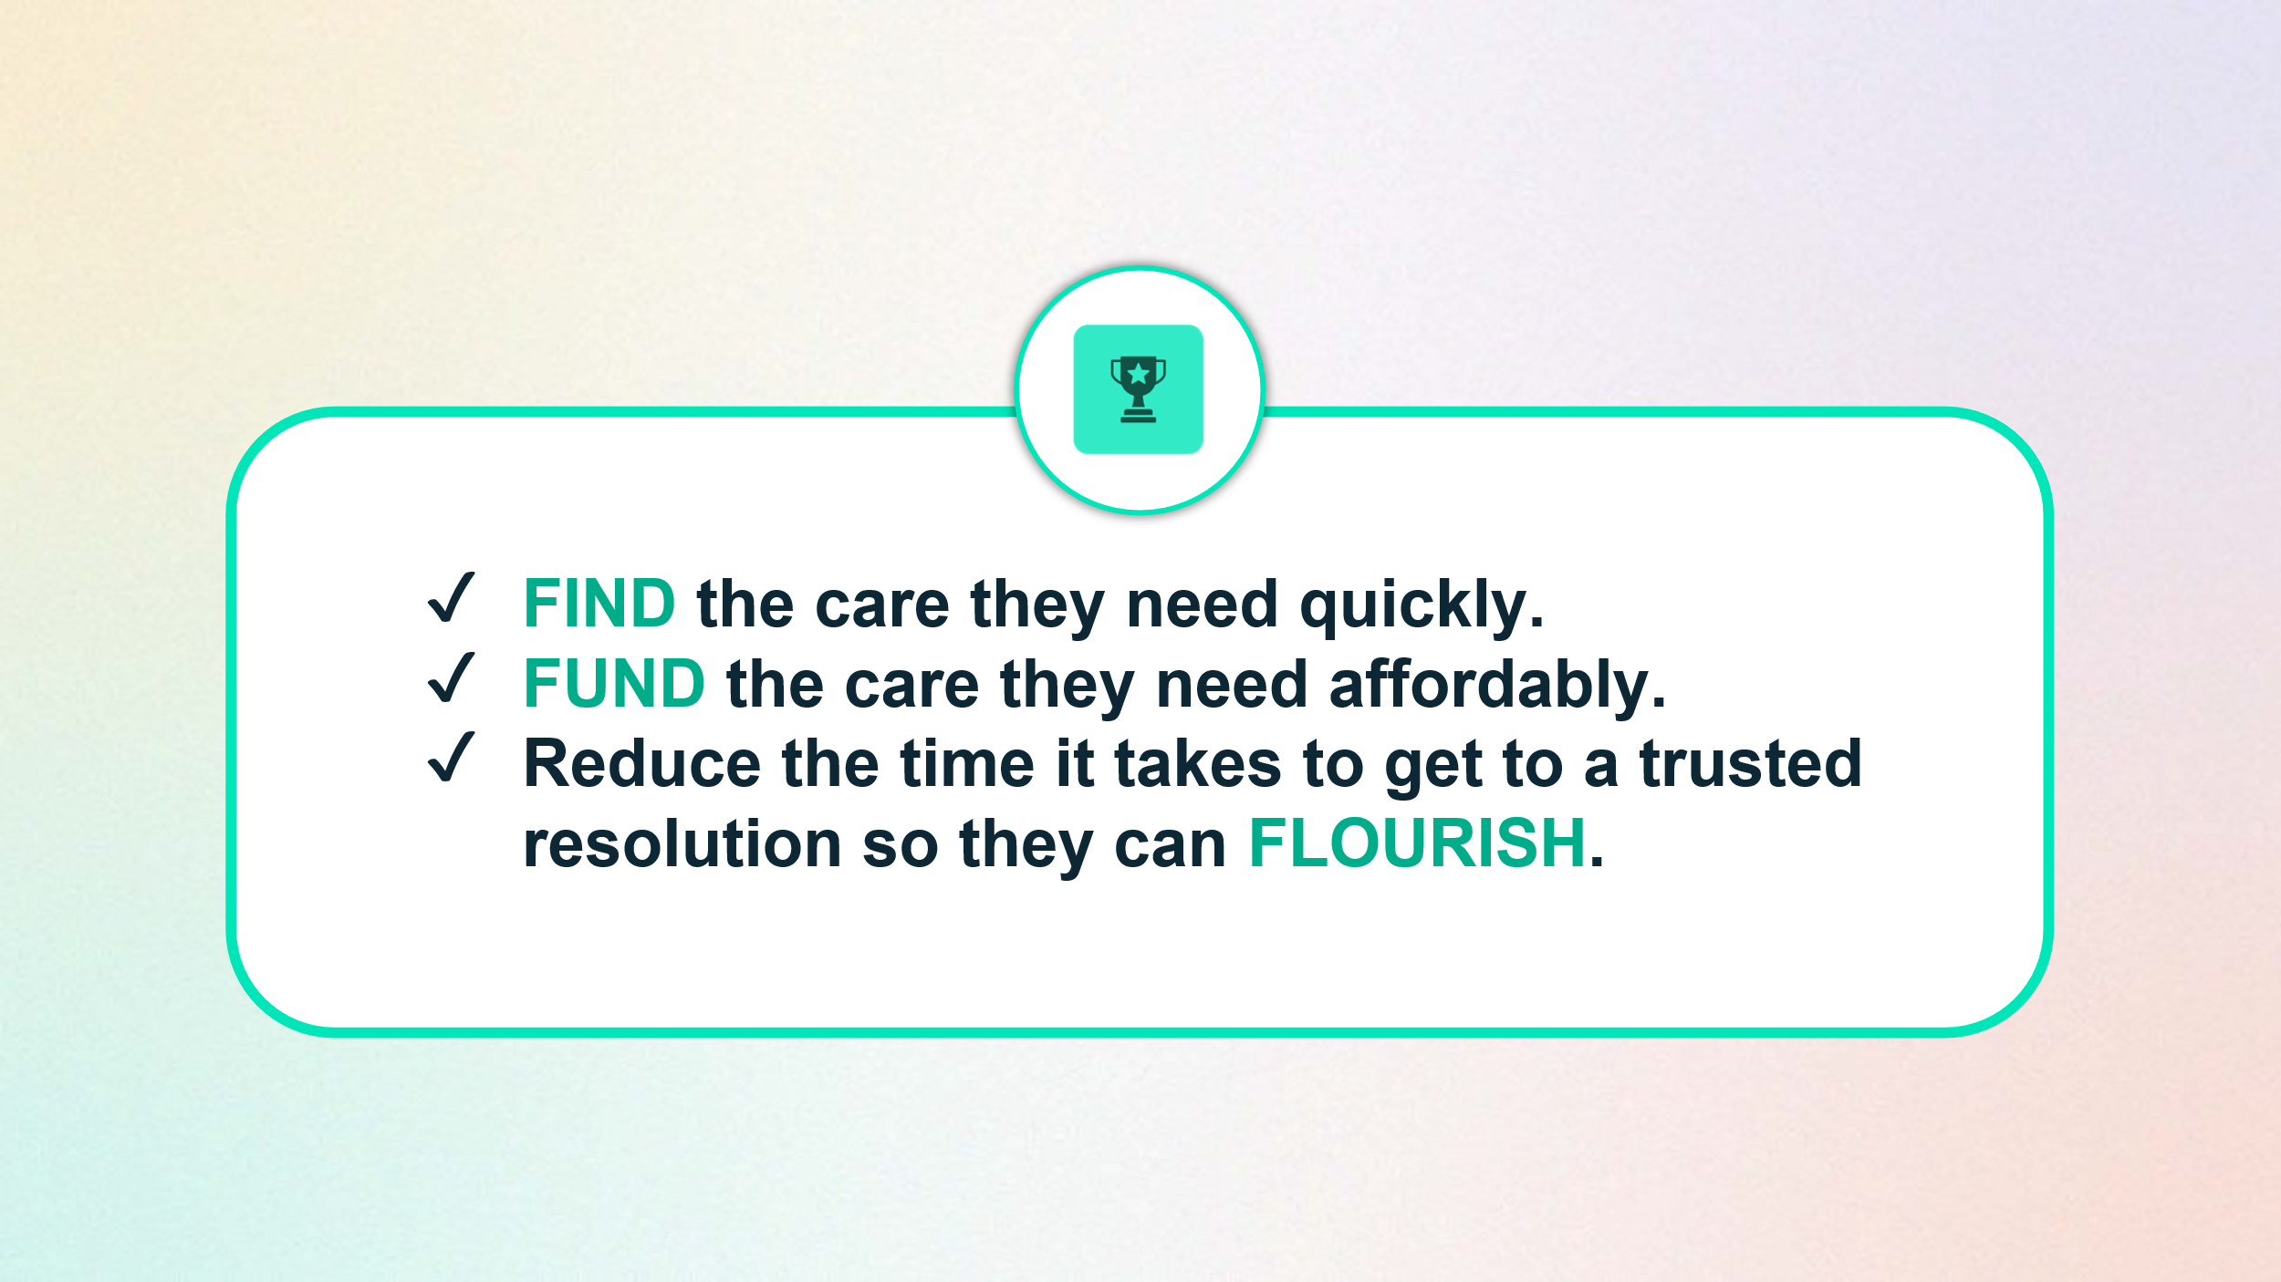
To achieve this, Simplyhealth has embarked on a radical transformation journey. With a trusted brand and a strong heritage in healthcare, it is uniquely placed to help change the landscape of healthcare in the UK.
The scale of this ambition and transformation is significant and requires energetic, ambitious, and digitally minded leaders to deliver against it.
The UK dental market, worth c.£9–11bn annually and growing rapidly in the private segment, presents a significant opportunity. Patients are increasingly turning to private care due to long NHS waiting times, rising treatment expectations, and an ageing population.

Role Overview
Over the past two years, Simplyhealth Group has operated Denplan (the market leader in dental plans) and Practi (a tech-driven startup for patient financing) as separate entities. With market consolidation, intensifying competition, and growing demand for digital solutions, maintaining separate businesses now risks inefficiency and margin erosion risk. Subject to the outcome of an ongoing consultation process, we are therefore proposing to bring these businesses together into a single Dental Line of Business.
As Managing Director, Denplan you will lead strategy, growth, and performance of our Denplan business, champion the customer – delivering what they really need – and unify existing lines into a single market-leading offering. As a member of the Executive Committee (ExCo), you will own the full P&L and be accountable for delivering revenue growth, profitability, and measurable customer value.
This role will suit a visionary, highly-commercial leader who combines strategic ambition with disciplined execution, inspiring teams to deliver innovative, customer-led solutions at scale.
Key Responsibilities & Accountabilities:

1. Strategy & Integration
- Define and deliver the long-term vision and strategy for the Dental Line of Business (LoB).
- Subject to the outcome of the current consultation process, lead the integration of Denplan and Practi into a simplified, scalable, and differentiated portfolio with a single operating model and coherent brand architecture.
- Align product roadmaps with wider Group priorities, technology strategy, and commercial targets.
- Shape and influence the broader Group strategy and capital allocation as a member of ExCo.

2. Commercial & P&L Leadership
- Own the profitability and performance of the Denplan LoB, delivering sustainable revenue growth and margin improvement.
- Partner with Finance to forecast, price competitively, and drive investment decisions.
- Monitor performance against forecasts, lead retention and margin strategies, and present results and outlook at ExCo, Board, leadership all-staff forums.

3. Sales & Marketing Leadership
- Assume direct accountability for Sales and Marketing within Dental, integrating previously central functions into the LoB
- Own go‑to‑market strategy across segments (practices, patients), channels (direct, partner, digital), and propositions.
- Set and manage pipeline, pricing/discount guardrails (within the Group’s pricing principles), demand generation, and performance marketing in partnership with Group brand governance.

4. Customer & Market Insight
- Act as the voice of the customer, ensuring practice and patient needs are embedded into strategy, product development, and service design.
- Leverage data and analytics to inform go-to-market strategies, optimise funnel conversion, and drive profitable growth.
- Represent the business at major industry events and conferences, strengthening our market presence and thought leadership.
- Ensure the voice of the customer feeds directly from the front line through to the product and engineering teams with critical insights systematically shaping future propositions.

5. Product & Innovation
- Assume direct accountability for Product & Innovation within Dental overseeing prioritisation and investment across the Dental portfolio, balancing innovation, compliance, and ROI.
- Establish governance for disciplined product lifecycle management, pricing and change control, and post-launch performance reviews.
- Champion digital-first, modular solutions that deliver measurable customer value and operational efficiency.

6. Leadership & Culture
- Lead and inspire senior teams across Product, Sales & Marketing, Clinical Services and Events.
- Foster a high-performance, product-led culture that thrives on collaboration, accountability, and innovation.
- Champion cross-functional alignment with Engineering, Service, Finance, Risk, and People to deliver unified outcomes.

7. Partnerships & External Influence
- Build and execute a scalable partnership strategy (including lenders/funding partners and professional bodies) to expand market reach and capability.
- Strengthen relationships with practices, partners, and industry stakeholders to enhance our value proposition and distribution.

8. Funding & Credit
- Oversee consumer financing propositions, working with Simplyhealth Funding Services (SFS) to secure capacity at a competitive cost of funds for patients.
- Ensure Consumer Duty and other compliance across customer journeys, disclosures, and operations.

9. Operational Excellence
- Drive simplification, automation, and efficiency to reduce cost-to-serve, improve quality, and accelerate speed to market.
- Embed a culture of continuous improvement, leveraging technology and data to scale effectively.

Regulatory Accountability
This role is designated as a Senior Manager under the FCA’s Senior Managers & Certification Regime. Appointment is subject to fitness and propriety assessments, annual reassessment, regulatory references, background checks, and conflict-of-interest declarations required.
Key Connections:
- Board, CEO, ExCo, Leadership Team
- Engineering, Service, Finance, People, Risk & Compliance, Legal, Data/Analytics
- External agencies, clients, practice partners, and lenders/funding partners
- Existing and potential partners and customers
- Dental conference delegates and professional bodies (eg, BDA)

Key Experience & Skills:

Strategic & Commercial Acumen
- Proven track record as a Managing Director, General Manager, or equivalent executive leader of a multi-product P&L.
- Proven track record in developing and executing end-to-end strategies that deliver growth and customer value.
- Demonstrated success in P&L ownership, forecasting, pricing, and delivering sustainable growth.
- Experience defining and executing differentiated propositions in competitive, regulated markets.
- Highly commercial; has delivered significant growth in both new and existing business lines and through partnerships

Leadership & Collaboration
- Inspirational leader with experience building and motivating high-performing teams.
- Able to engage well with people of different backgrounds and seniorities.
- Skilled at influencing across matrixed organisations and aligning diverse stakeholders around clear priorities and outcomes.
- Executive presence with outstanding communication skills for internal and external audiences.
- Inspirational leadership style with a hands-on approach and high bias to action.

Product & Market Expertise
- Deep experience in product-led growth, proposition development, and go-to-market strategy.
- Strong understanding of customer lifecycle management, segmentation, and digital innovation.
- Passion for healthcare innovation and improving patient outcomes; dental sector experience advantageous but not essential.
Dental Customers & Practices

- Passionate about understanding practice and patient needs and behaviours, with a track record of incorporating insights into product and service development.
- Ability to represent the voice of our Dental patients and dentists at ExCo/Board level and in strategic decisions.

Data-Driven & Innovative
- Analytical mindset with proven ability to use data to inform strategy, pricing and performance.
- Experience leading transformation, modernisation, and digital-first initiatives.
- Comfortable navigating ambiguity and driving change in fast-paced environments.
- Proven experience of delivering growth through digital and alternative channels.
Innovation & Change Leadership

- A ‘digital-first’ mindset with a test-and-learn approach.
- Adept at navigating ambiguity and leading change in fast-paced, evolving environments.

Why Join Us
This is a rare opportunity to shape the future of a market-leading Dental business, influence strategy at ExCo level, and deliver meaningful impact for practices, patients, and partners. You will lead a talented team, drive innovation, and play a pivotal role in transforming customer experience in a high-growth sector.

Our Culture and Values
We need to act with courage and curiosity to unlock opportunities for customers, colleagues, and communities. We operate with trust and kindness delivering what customers need and supporting colleagues to be their best. We live our All together healthier ethos, focusing on self-care and nurturing relationships.

Simplyhealth’s cultural ambition can be summarised as doing the right thing: by its customers, its people, its communities and our planet. It seeks individuals who have passion and energy, who believe in a commercial agenda but who also believe the outcome of Simplyhealth’s commercial endeavours can lead to a better life and a healthier planet.

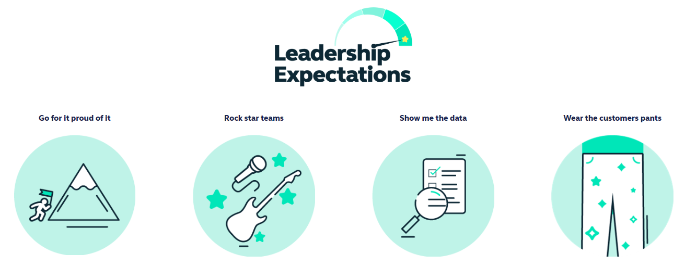

Health and access to healthcare have never been more important. With this comes endless exciting possibilities for innovation and growth. The market is evolving quickly, and we’re committed to leading-edge solutions our customers expect and deserve, now and for generations to come.

By reinventing ourselves, we will reach more customers, expand access to affordable healthcare, and unlock our growth potential. This next chapter is about transformational change.

To make this a reality, we will challenge our ways of working while keeping the customer at the heart of everything we do.
- Andover based role, with regular attendance at our Hampshire head office; ‘smart working’ with flexible remote working
- Some UK travel and overnight stays
- Reasonable role and task flexibility expected, given the seniority of the role
- Maybe required to lead projects or initiatives in other parts of the Simplyhealth Group

